[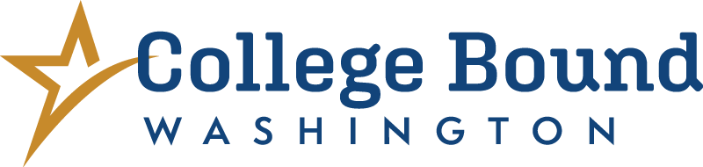](https://wsac.wa.gov/college-bound)

**🎓 Washington State’s College Bound Program 🎓**

**Your future starts now—College Bound can help!**

**Why College Bound Matters**

Planning for college or technical school after high school? The [**College Bound program**](https://wsac.wa.gov/college-bound) can help make it more **affordable** so you can follow your dreams—whether you want to be a nurse, a mechanic, a video game designer, or run your own business.

**Education after high school helps you:**

* Learn new skills
* Get better job opportunities
* Earn more money over time
* Do what you love

**💰 What is College Bound?**

**College Bound is financial aid** from Washington State to help you pay for college or job training. If you meet the program’s requirements, you could get help paying for:

* Tuition (at public college rates)
* Some school fees
* A small amount for books

You can use College Bound at [**about 60 colleges, universities, and technical schools**](https://wsac.wa.gov/sfa-institutions) across Washington!

College Bound combines with other state financial aid, usually the [**Washington College Grant**](https://wsac.wa.gov/wcg), one of the most generous financial aid programs in the country. Together, these programs could even make college or technical school **free**, depending on your family’s income.

**🧩 Who is eligible for College Bound?**

If you are income-eligible and signed up for **free or reduced-price lunch** in 7th, 8th, or newly income eligible in 9th grade, you are **automatically enrolled** in the College Bound program. Ask your school counselor to confirm!

**✅ College Bound Rules**

To get College Bound funds after high school, you must:

* Graduate from a Washington high school or earn a GED in WA
* Keep at least a **2.0 GPA** if you’re going straight to a 4-year college  
  *(No GPA requirement if you’re attending a community or technical college in WA)*
* Enroll in college or career school **within 1 year** of high school graduation
* Have **no felony convictions**
* **Apply for financial aid** (FAFSA or WASFA) your senior year and every year after  
  *(Colleges will use this to check your income and residency each year)*

**Important:** College Bound is a great opportunity but not guaranteed. Students must meet all program requirements, including income and residency, each year they are enrolled in college or job training. College Bound can be used within six years of college enrollment or until you earn a bachelor’s degree, whichever comes first.

**📱 Tools for All High School Students & Families**

[](https://wsac.wa.gov/otterbot)**OtterBot** – Your college planning and financial aid text buddy!  
Get help with financial aid and college planning by text. 📲**Scan the QR code** to sign up for OtterBot.

* **Students**: Text **"Hi Otter" to 360-928-7281** or sign up [here](https://hello.mainstay.com/OtterBotStudent)
* **Parents/Guardians**: Text **"Hi Otter" to 360-634-0354** or sign up [here](https://hello.mainstay.com/OtterBotParent)

[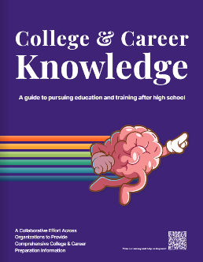](https://wsac.wa.gov/12th-year-campaign#college-career-knowledge-handouts)**College & Career Knowledge Book**  
Explore this digital guide—available in 7 languages—to learn how to prepare for life after high school. 👉 Download the guide [here](https://wsac.wa.gov/12th-year-campaign#college-career-knowledge-handouts)

**Have Questions?**

Contact **[School Staff Name]** at **[email] / [phone]**

Email: [**collegebound@wsac.wa.gov**](mailto:collegebound@wsac.wa.gov)  
Call: **888-535-0747 (Option 1)**  
Visit: [**collegebound.wa.gov**](https://www.collegebound.wa.gov)