Dear [College Bound student first & last name],

🎉**Congratulations!** 🎉You are officially enrolled inthe **Washington State College Bound program!**

**You are receiving this letter as confirmation of your enrollment in the College Bound program. Your eligibility was confirmed by staff at our school.** As a College Bound student, you will likely receive an email, mailing, or other form of communication in the years to come reminding you of this amazing opportunity. Now that you have been introduced, reach out to College Bound or school staff about what this means for you!

**What is College Bound?**

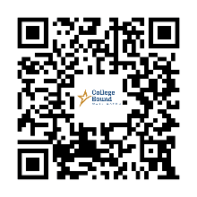College Bound is an early commitment of financial aid from Washington State. It works with other state financial aid, like the Washington College Grant, to help pay for your education after high school. If you meet the program requirements, you could receive funding for:

* Tuition (at public college rates)
* Some fees
* A small amount for books

This funding is available at **over 65 colleges, universities, and technical schools** in Washington!

**What does being a College Bound student mean?** Scan the QR code above to learn what the College Bound Pledge requirements are.

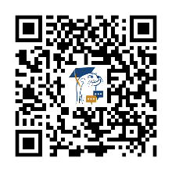**Stay Connected!**

**OtterBot** is a free texting service for College Bound high school students and their parents/guardians. You will receive regular messages about financial aid, college planning, and reminders. Plus, you can text anytime for help! **Sign up now using the QR code or visit** [**bit.ly/CBContactFormCertEng**](https://bit.ly/CBContactFormCertEng)**!**

**Got Questions?**

You can reach the College Bound staff at [collegebound@wsac.wa.gov](mailto:collegebound@wsac.wa.gov) or call 888-535-0747, option 1. Visit the College Bound website at [collegebound.wa.gov](https://wsac.wa.gov/college-bound) for more information.

This is a fantastic opportunity, and I’m excited to support you on this journey!

If you have any questions or need more information, please contact me at (insert counselor or school staff’s email address) or (insert phone number)

Thank you,

Counselor Name

Counselor at (School Name)