How to Complete the WASFA

Washington Application for State Financial Aid

wsac.wa.gov/wasfa

Updated 10/10/2022

Overview (1 of 3)

WASFA Privacy Statement
The Washington Student Achievement Council (WSAC) administers state financial aid including the Washington College Grant, the College Bound Scholarship, and the Washington Application for State Financial Aid, or WASFA, for undocumented individuals. The Council is committed to providing opportunities and support to ensure every Washington student is able to pursue education beyond high school.

Regarding concerns that students, parents, and other partners may have about the confidentiality of information submitted on the WASFA, the purpose of the application is to provide eligibility information to colleges and universities in Washington that offer the Washington College Grant and the College Bound Scholarship. WSAC shares application information with campuses listed by the student so those schools may determine eligibility for resident tuition and financial aid. Campuses are not permitted to use the information for other purposes or share the data with other parties.

WSAC is committed to protecting the confidentiality of the information and privacy of students and families. Washington is a state committed to providing opportunities to students and protecting the rights of families.

Overview (2 of 3)

State Financial Aid for Undocumented Students and Other Select Applicants
The Washington Application for State Financial Aid (WASFA) is for people who don’t file a federal FAFSA application. People who complete a WASFA are applying for state aid.
There are various reasons to complete a WASFA instead of a FAFSA:
- Immigration status, or student is undocumented
- Undocumented parents or family members do not wish to file a FAFSA
- Defaulted federal loans
- Repayments owed on federal grants
- Inability to provide selective service confirmation

Overview (3 of 3)

The WASFA application can be found at wsac.wa.gov/wasfa. The following instructions will aid you in successfully completing the WASFA.
- New users completing the WASFA questionnaire for the first time will be asked a series of questions to determine if the WASFA is the appropriate financial aid application to complete. If it is, a link to the WASFA application is provided. If not, a link to the FAFSA is provided.
- Returning users wanting to create a new application, or to make corrections to an existing application, please select the Returning User button and select the appropriate link that matches the Returning User scenario.

Please do not create a new account. Contact us via email at: wasfa@wsac.wa.gov if you are unable to access your account.

Select New User or Returning User.
New User or Returning User?
New Users will be asked a series of eligibility questions to ensure the WASFA is the correct application before bringing the User to the login page to create a new account.

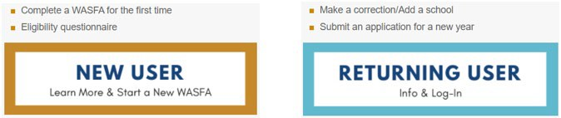

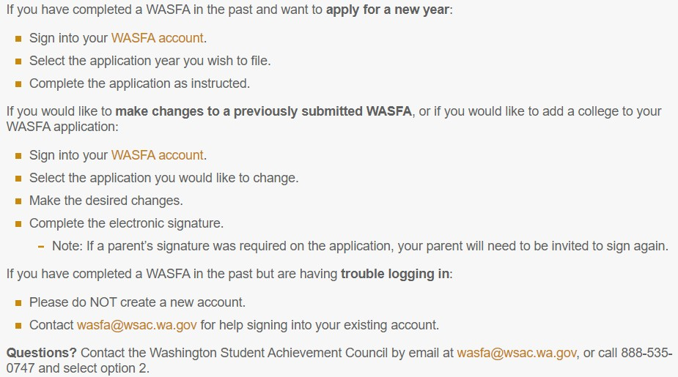Returning User Screen

Choose which Returning User scenario applies to you.

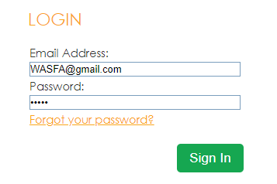

Returning User – Forgot Password or Security Answer

If you have forgotten your PASSWORD, please click on the “Forgot your password” link from the sign in page. You will be prompted to enter the email address you used when you registered, and a security code that is provided for you.
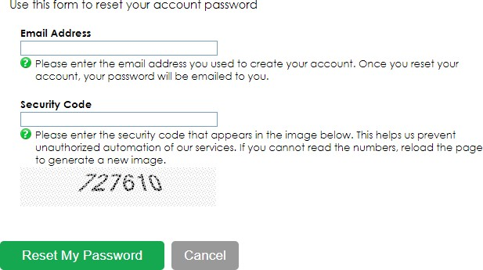
You will receive an email with a temporary password directing you back to the site to login. You will need to know the security answer you provided when you created your account to login with the new password.
If you have forgotten your SECURITY ANSWER contact WSAC at 888-535-0747, Option 2, or wasfa@wsac.wa.gov. Do not create a new account.

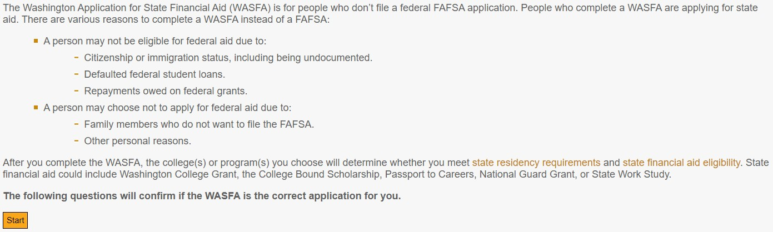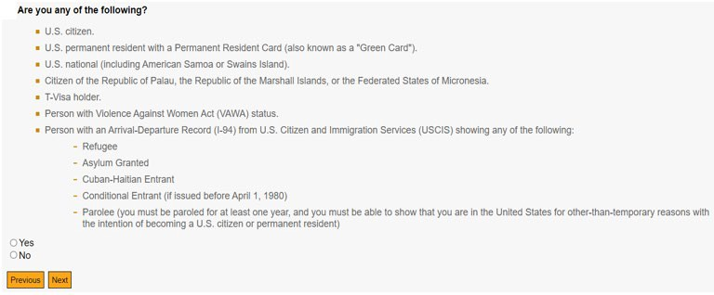

Eligibility Questions for New Users

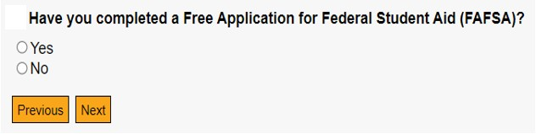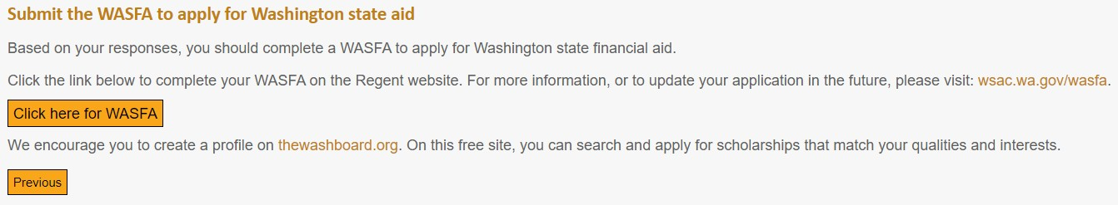

Create New Account – Step 1

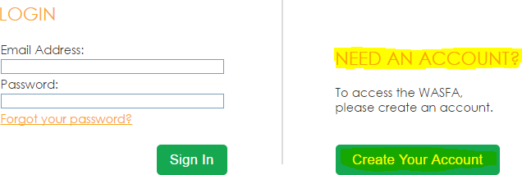

To begin, create an account by selecting the Create Your Account button on the screen shown to the right.

Create New Account – Step 2

Answer another FAFSA Eligibility Question. If eligible for FAFSA, applicant will be redirected to the FAFSA site. If not, applicant will continue to fill out WASFA application.

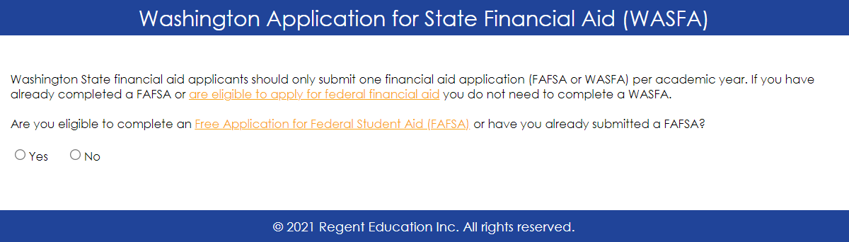

Create new account – Step 3

Register for new WASFA Account
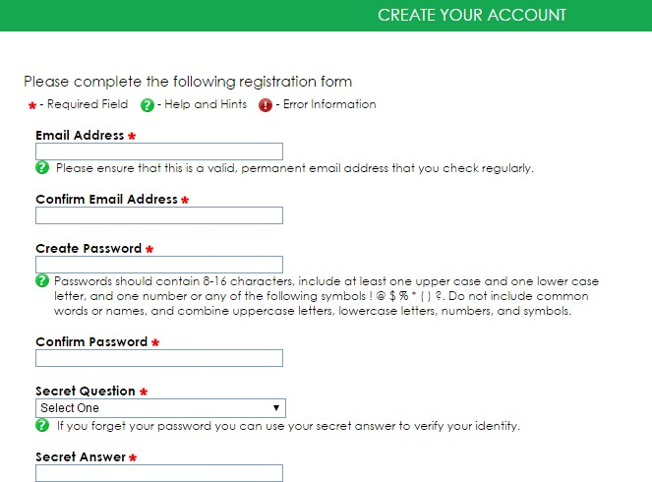

Please use an email you will be able to check regularly such as a personal gmail account and not a school email.

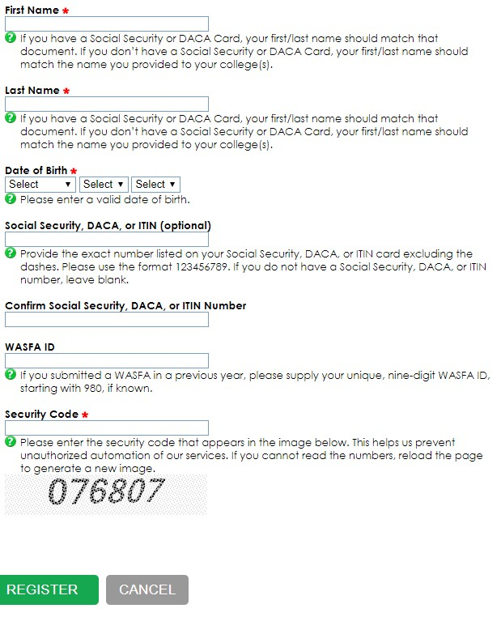Create new account – Step 3 Continued

Register for new WASFA account

What numbers do I use?
- If you have a SSN, DACA, or ITIN, enter it here. If you don’t, leave blank.

- If you previously applied under a 980 WASFA ID and now have a SSN, DACA, or ITIN, enter both SSN, DACA, or ITIN and WASFA ID fields.

- If you previously applied and know your WASFA ID, enter that WASFA ID. (Unique nine-digit ID starting with 980)

- If you have never applied before and do not have a SSN, DACA, or ITIN nor a WASFA ID, leave all SSN, DACA, or ITIN and WASFA ID fields blank.

What numbers do I use?

Prepare to Start the WASFA

What you will need to complete the WASFA
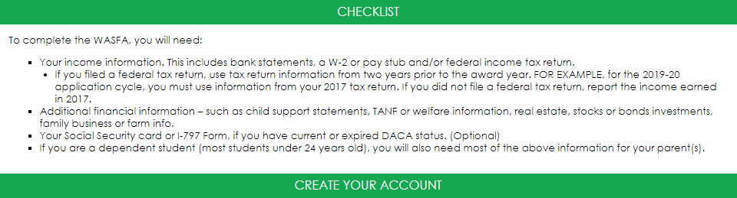

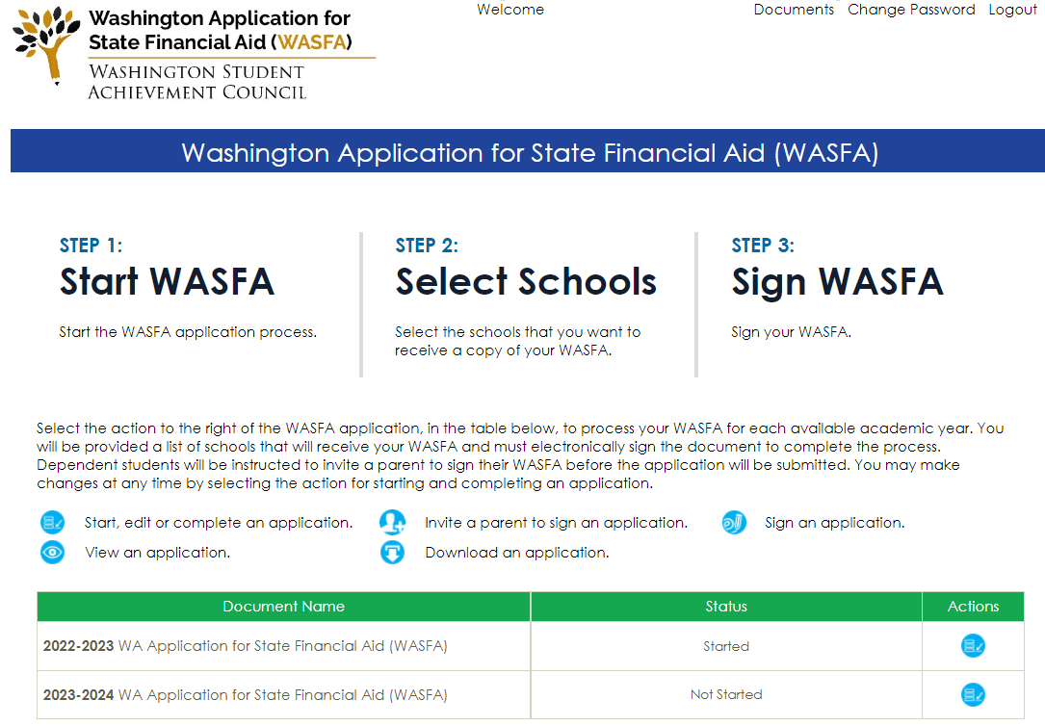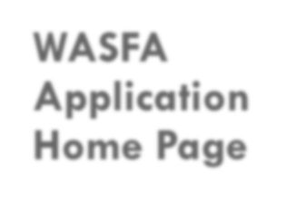
WASFA
Application Home Page

Once you have logged into your account, this will be your WASFA home page.
It has a list of all available WASFA applications and their current status:

Starting the WASFA
Select:

for the application year you want to start.
There may be times that there are multiple application years open. Be sure to pick the year that you will be attending college. For example, if plan on attending school in the Fall or Spring of 2023, you would choose the 2023- 2024 application year.

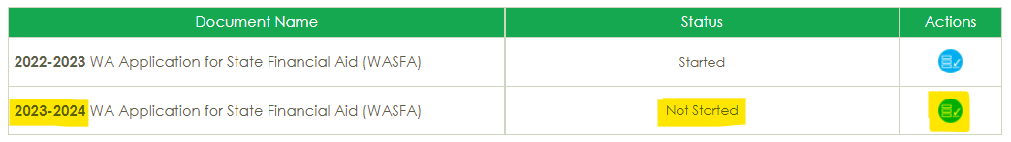

Application in Progress

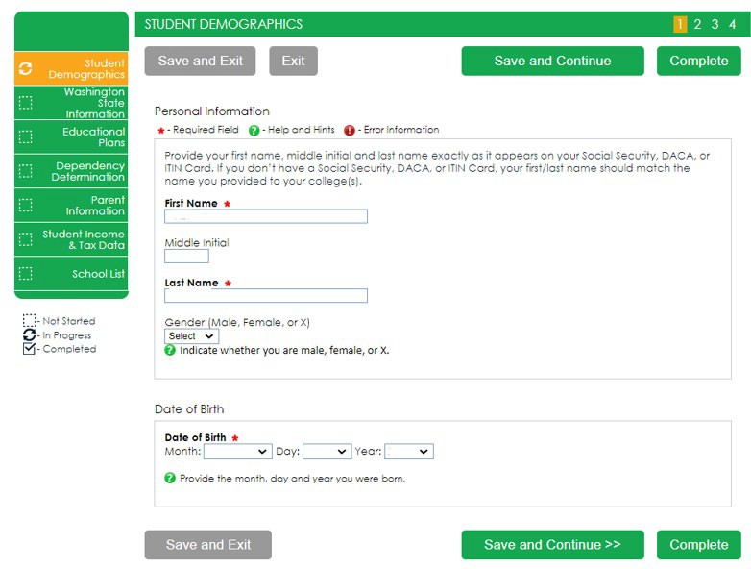Upon clicking the “Start, edit, or complete an application” button from the WASFA homepage, you will begin the application process.
Answer the questions and click on the “Save and Continue” button to continue moving through the application process.

Application in Progress (1 of 2)

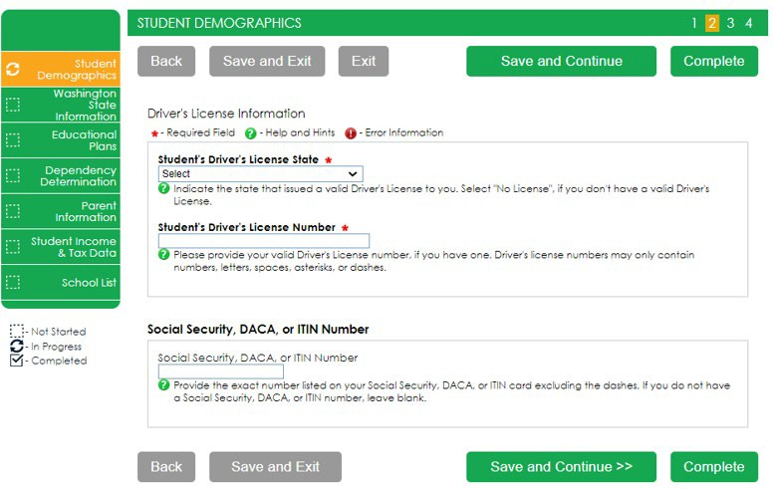As you move through the application process, the green menu on the left side will tell you what section you are on, and the numbers in the top green bar will tell you how many parts are in that section, and what part you are on. You need to hit “Save and Continue” on every page.

Application in Progress (2 of 2)

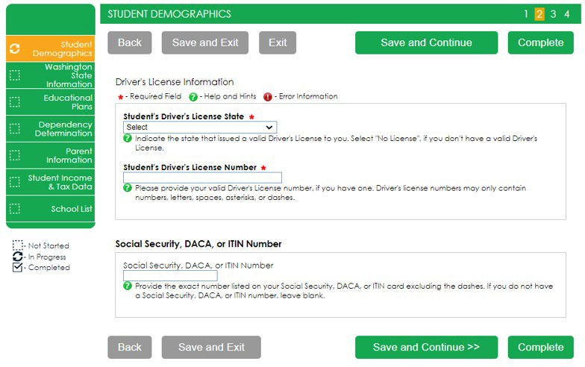The following instructions will not show a screen shot for every question, however we will highlight a few of the areas asked about most often.

The section and page number within the section we are discussing is circled in red in the left green menu and top green bar.

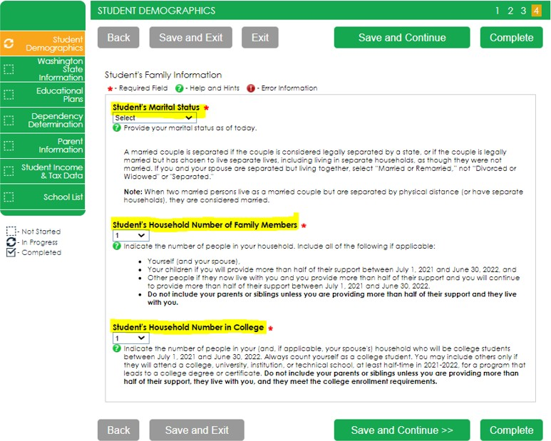
Family Size Information
On Student’s Family Information answer all questions as they relate to only the student and who the student financially supports. “Student’s Household Number of Family Members” should only count dependents the student financially supports by themselves. Same for number in college.
Example: If a student is unmarried with no children of their own, and is not financially responsible for anyone else, the student’s household number is 1, and the student’s number in college is 1. Other family members, such as parents and siblings, will be captured in the Parent’s section.

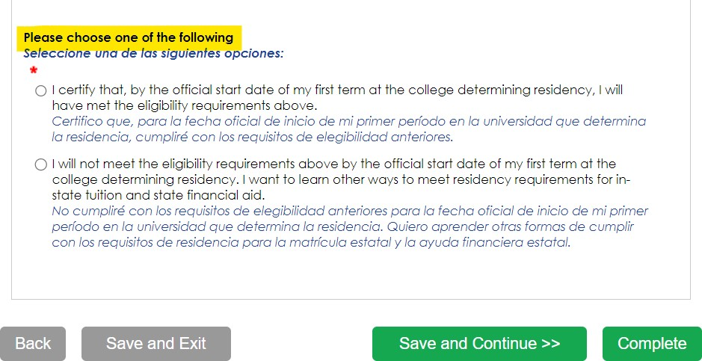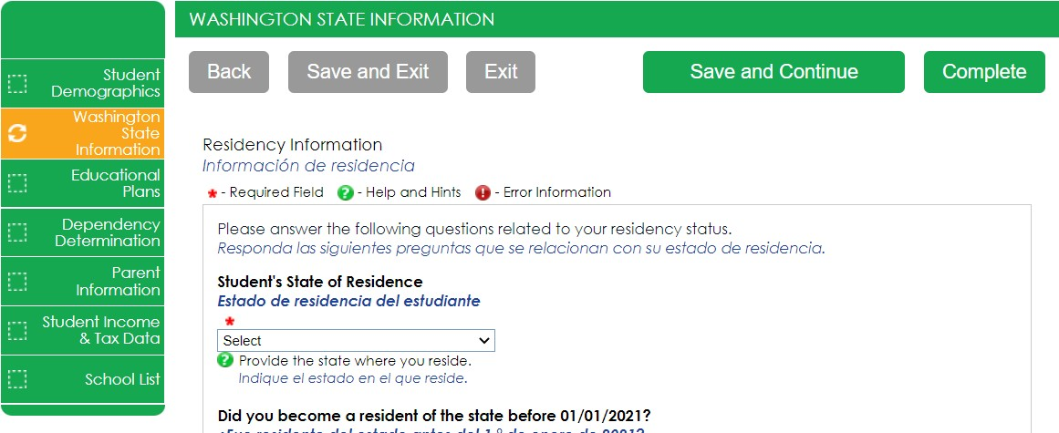Answer all the residency questions carefully and accurately. The residency law changed on July 25, 2021, making it easier for more students to qualify.
New Residency Information

In this section, you are certifying that you meet the requirements shown in the: “WA State Higher Education Residency Affidavit” and “Certification Regarding Permanent Residency Application and Related Responsibilities.” Please read the descriptions carefully. (Sample affidavit on next page)
Choosing “I will not meet” will open questions for you to answer regarding DACA.

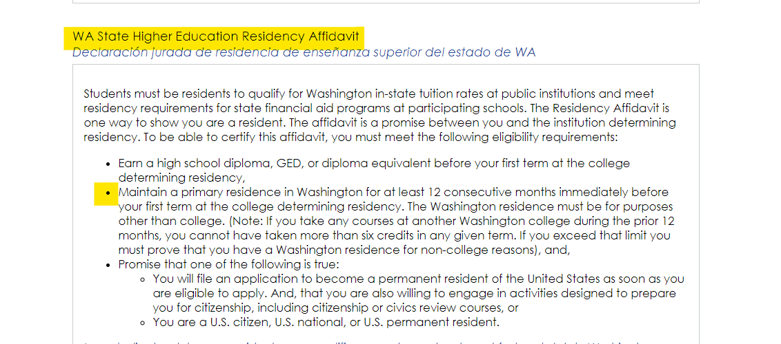Residency Affidavit Update

NEW REQUIREMENT AS OF
6/9/22: The Washington residence must be for purposes other than college. reasons.

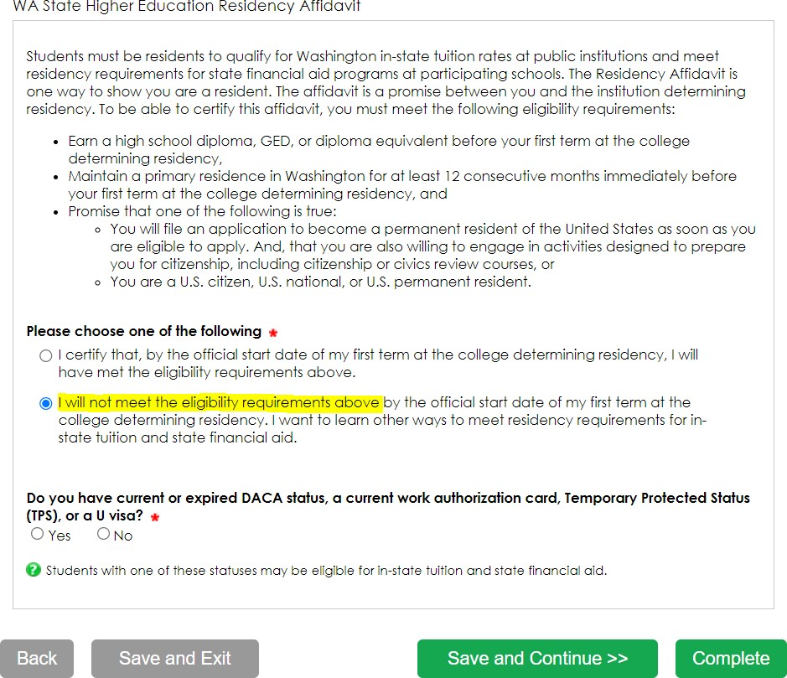
Residency Information
On Residency Information answer all the residency questions carefully and accurately.
If you answer “I will not meet the eligibility requirements” in this section, you will need to answer the DACA question, then click Save and Continue.
If you answer “No” to the DACA question, continue filling out the WASFA to the end. Your school will determine if you meet eligibility based on the information you provide.
Note: You will not get the DACA question if you answered, “I certify that, by the official start date of my first term at the college determining residency, I will have met the eligibility requirements above.”

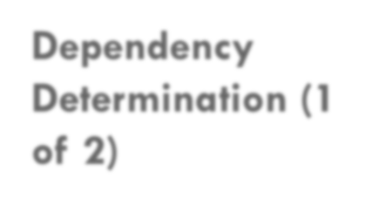
Dependency Determination (1
of 2)

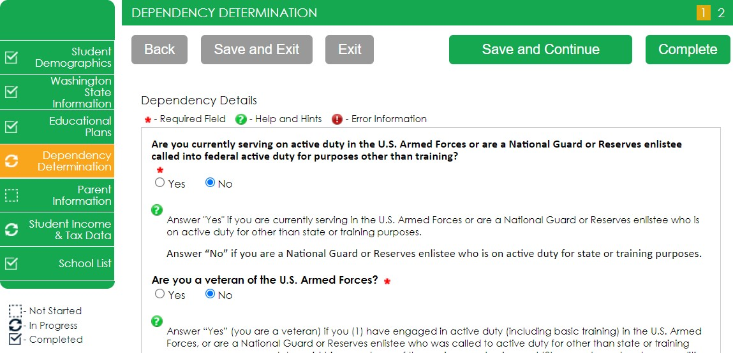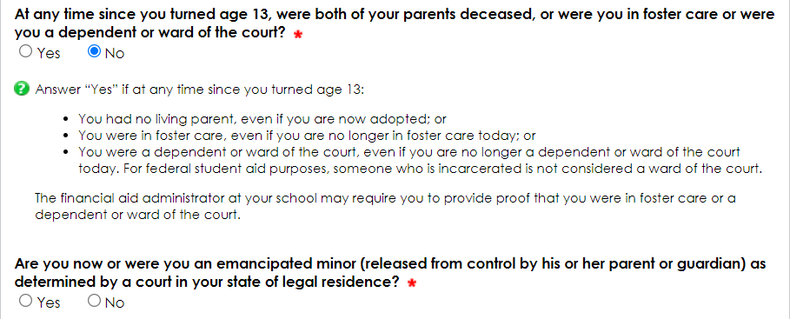On Dependency Determination answer all the residency questions carefully and accurately.

This section determines if you are considered a “dependent” student or an “independent” student. Please read the descriptions carefully. Answering “Yes” to any of these questions will mark you as an “independent” student and you will not be asked to enter any parent information or require a parent signature.

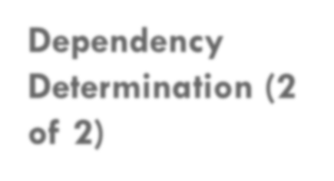
Dependency Determination (2
of 2)
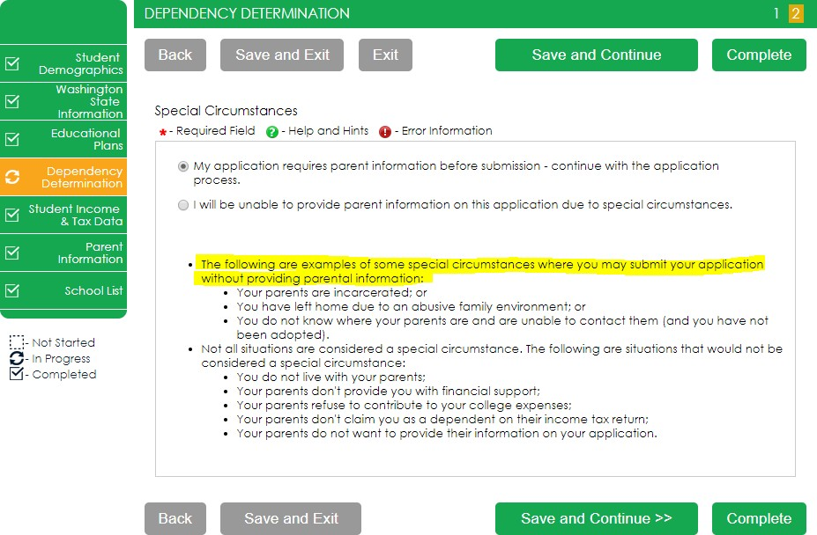SPECIAL CIRCUMSTANCES
If you are determined to be a “dependent” student, you will be required to answer questions about your parents.
Most people will fall into this category.
You may be able to submit your application without parent information under special circumstances if you meet outlined criteria. Your financial aid office will either approve or request for you to submit your parent information.
Note: Claiming special circumstances when you do not qualify may delay the processing of your application.

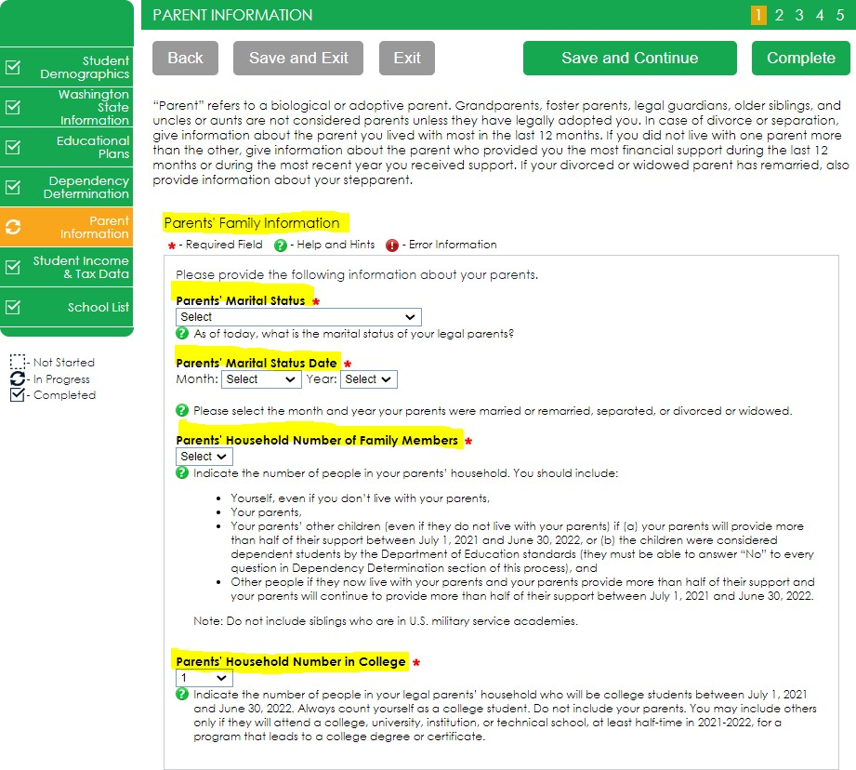
Parent Information (1 of 4)

For Parent Information answer all questions as they relate to the parent/s and all the people they are responsible for supporting (including you).

Example: If a student has 2 siblings also in college, parent has never been married, the parent household number is 4, and the parent number in college is 3.

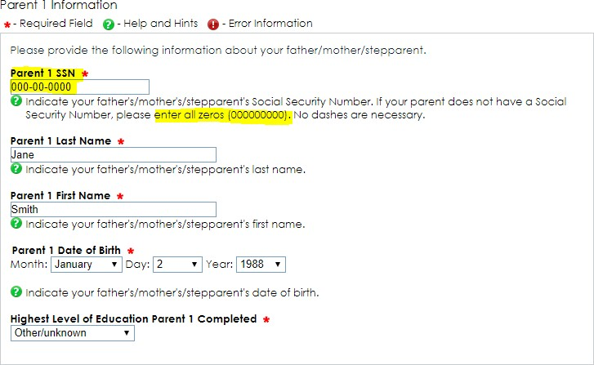
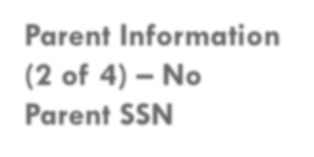
Parent Information (2 of 4) – No
Parent SSN
If your parent/s do not have a Social Security Number enter all zeroes (do not put in random
numbers).
IMPORTANT:
Parent/s do not need a Social Security Number for their child to apply for financial aid.

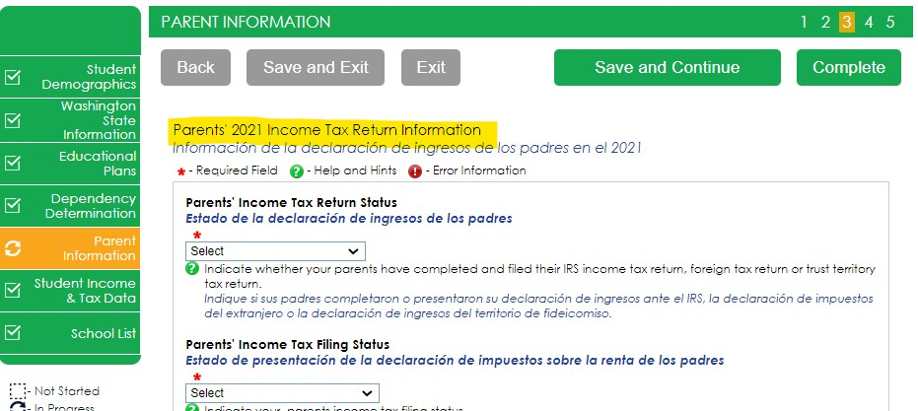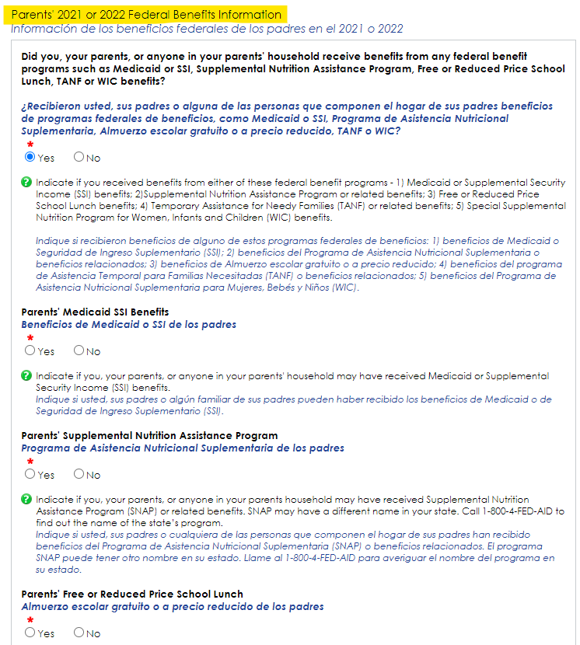Parent Information (3 of 4)

For Parent Information answer all questions as they relate to the parent/s.
If the family receives federal benefits such as Medicaid, SSI, food assistance, free or reduced-price school lunch or any other assistance, those numbers will be captured on this page under the Parents’ 2020 or 2021 Federal Benefits Information.

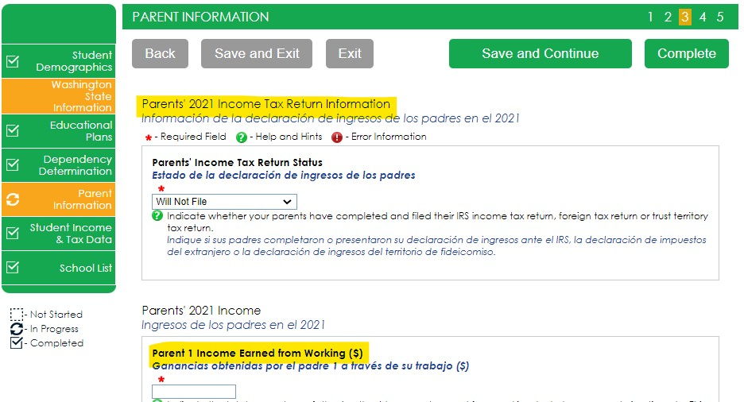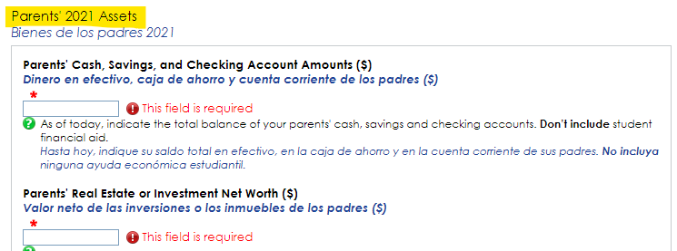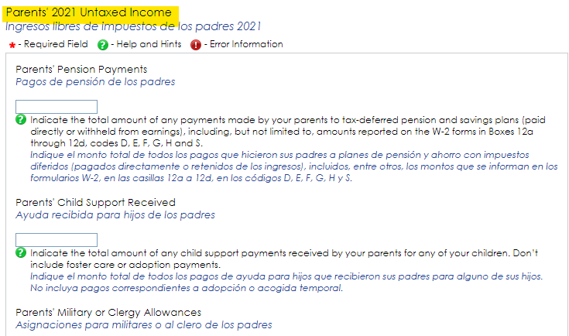Parent Information (4 of 4)

Parents’ and students, are not required to file taxes to receive state aid. However, if income reported is $50,000 and over, questions regarding assets and untaxed income will need to be estimated using bank statements, paystubs, etc.

Student Income and Tax Data

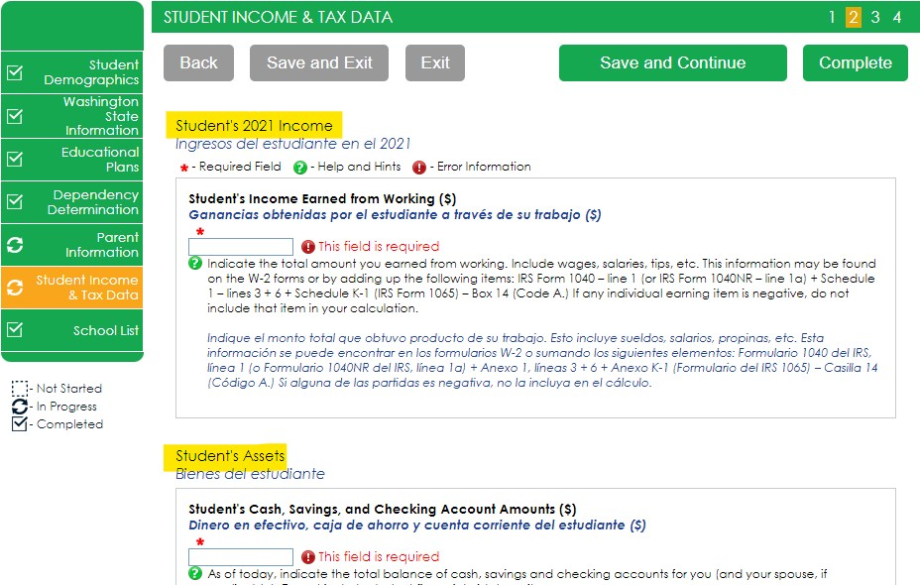On Student Income & Tax Data answer all questions as they relate to only the student, including additional income and federal benefits. If the family receives food assistance or other assistance, those numbers will be captured in the parent section of the application.

School Selection

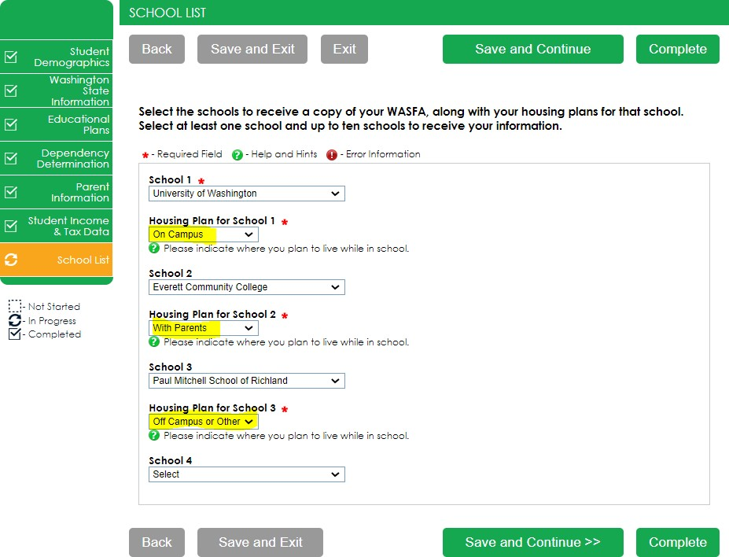Select the schools you are considering attending, even if you haven’t applied or been accepted. You may choose up to 10 schools. This will allow you to get your financial aid application submitted to assist in meeting any financial aid priority deadlines schools might have in place.

If you want to live on campus, or don’t know what your housing plan will be yet, select “On Campus”

If you don’t know what your housing plan will be, select “On Campus.” If you change your mind later, let the financial aid office know.

Preview Application Responses
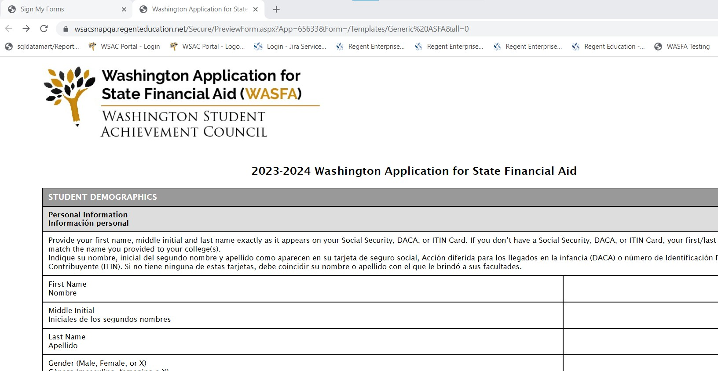
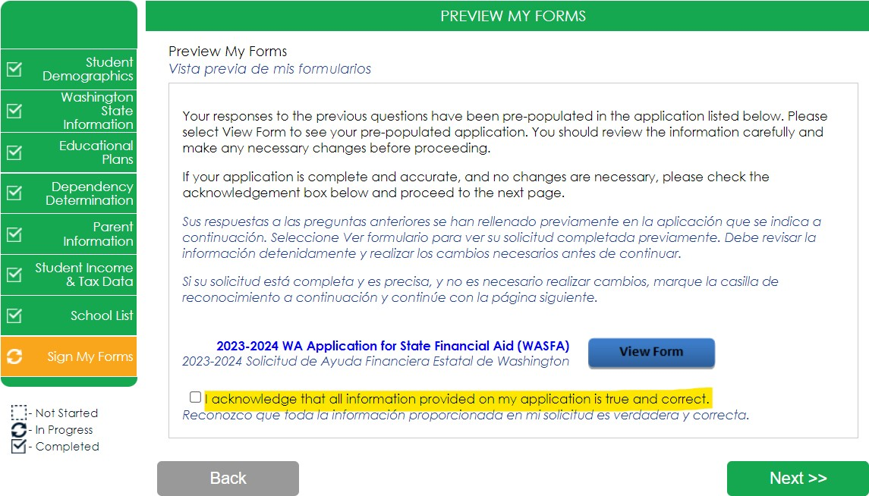Sign My Forms – The Preview My Forms section is an opportunity to review all your answers by clicking on the View Form button. You MUST open and preview this form before you can acknowledge that the information is true and correct.
The form will open in a separate tab. Once you have viewed it you can close the tab, check the box acknowledging your information is true
and correct,
Review answers carefully and make corrections prior to signing.
then click Next.

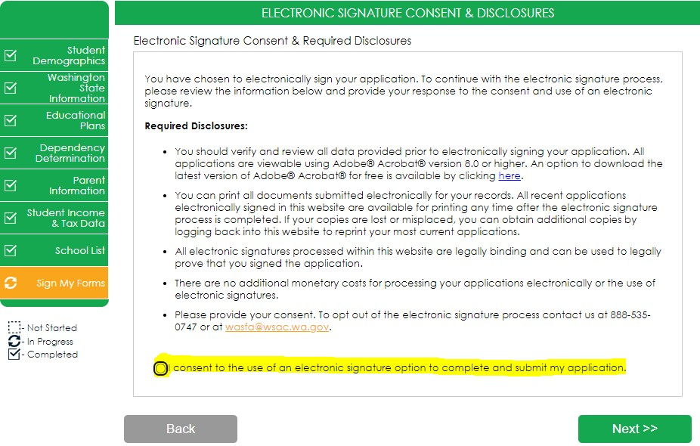Electronic Signature (1 of 3)

Sign My Forms – Electronic Signature Consent & Disclosures.
Please read disclosures and select the “I consent to the use of an electronic signature option to complete and submit my application.” Then click Next.

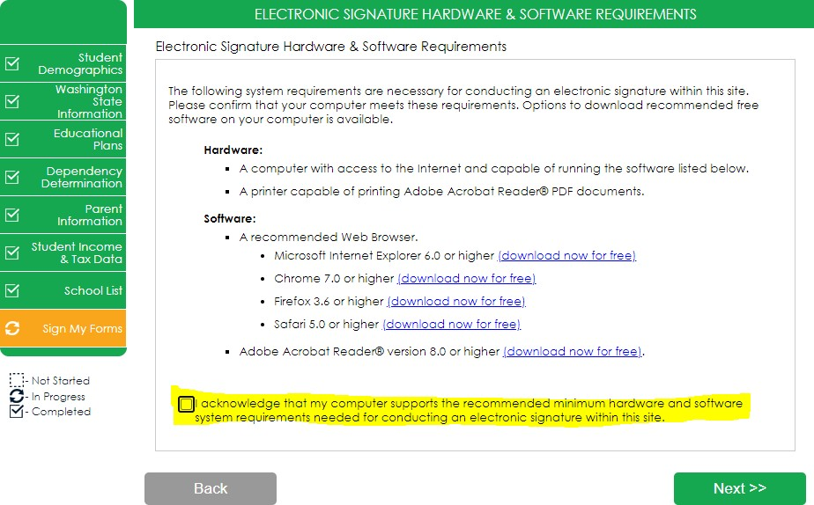Sign My Forms – Electronic Signature Hardware & Software Requirements.
Electronic Signature (2 of 3)
Please read the system requirements and select the “I acknowledge that my computer supports the recommended minimum hardware and software system requirements needed for conducting an electronic signature within this site.” Then click Next.

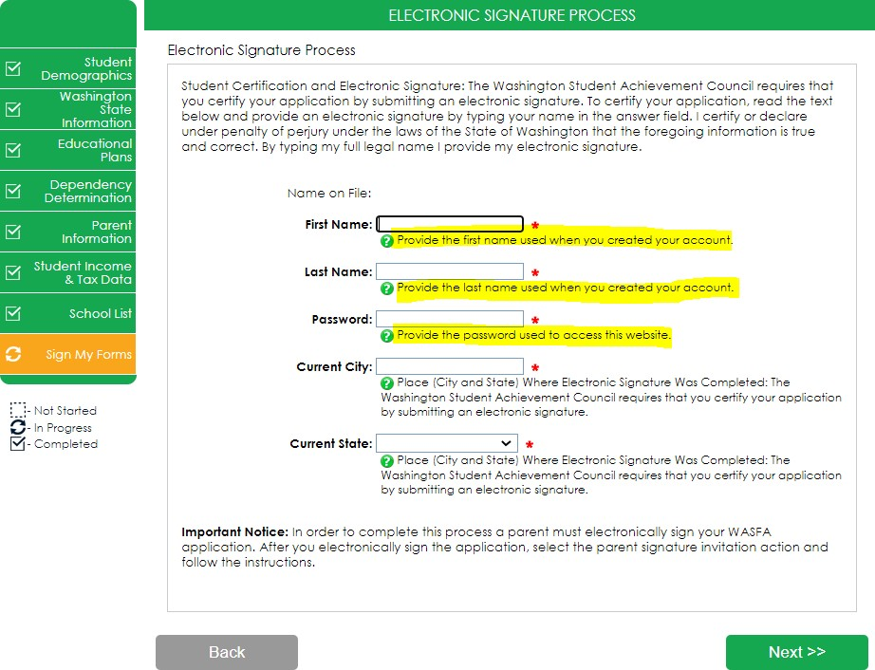
Electronic Signature (3 of 3)

Sign My Forms – Electronic Signature Process. Please read the disclosures you are certifying when electronically signing your application that state you are certifying the information you provided is true and correct.
Name and password information entered must be exactly the same as when you created your student account.
Then click Next.

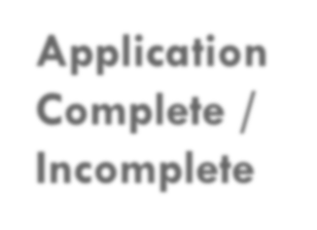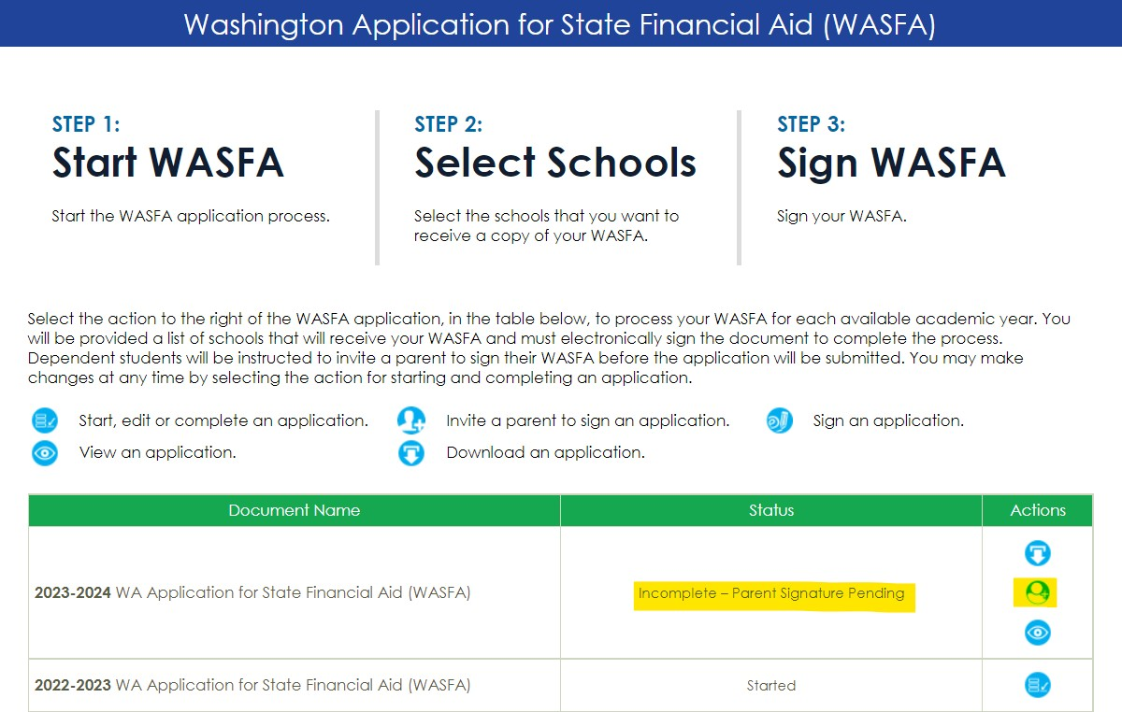Application Complete / Incomplete
Once you complete the electronic signature section, you will be redirected to the WASFA home site. If you are an independent student, your application is complete and will be sent to your prospective schools within 24 hours. YOU WILL NOT RECEIVE AN EMAIL CONFIRMATION.
If you are a dependent student, you will need to invite your parents to electronically sign your application. To invite a parent, click on the
button in the Actions column that is highlighted to the right.

Parent Signature Process

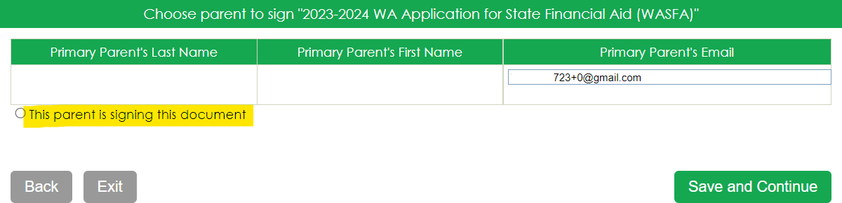Once you click on the “invite a parent to sign an application” button in the Actions column, it will bring up your parent choices.
parent
name
IMPORTANT:
The parent email address cannot be the same email address the student used to create the account, and the parent must use this email address to create their parent account to be able to sign and submit the student’s application.
Choose only one parent and make sure their email address is correct. If necessary, correct or update the email address, then click on the Save and Continue button.

Confirm Parent Selection

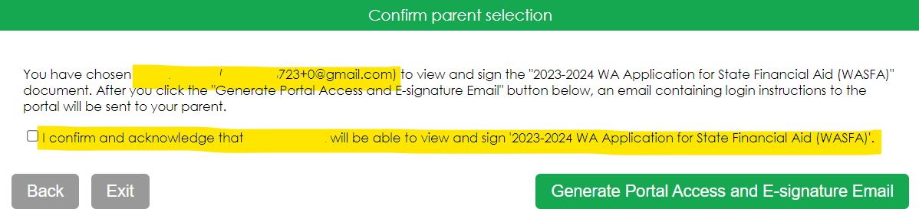Once you click on the Save and Continue button, it will ask to confirm your parent selection.
Parent name
Check the box confirming your parent selection, make sure the email address is correct, and click on the Generate Portal Access and E-Signature Email.

Parent Signature Process (1 of 7)

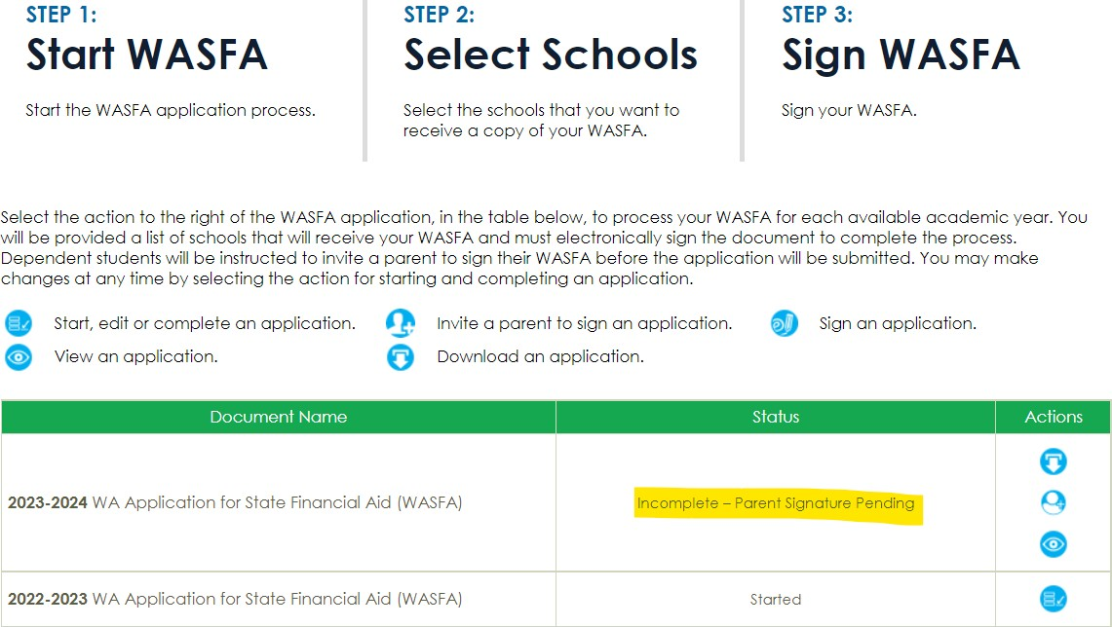Once you select the Generate Portal Access and E-Signature Email, it will redirect you back to the WASFA home page where it will still say your application is “Incomplete-Parent Signature Pending” until your parent signs.
Logout of your account. Your parent will receive an email with a link to create their own account and to electronically sign your application. This link expires in 72 hours.
If your link has expired, log back into your student account and send a new invitation. Once your parent has electronically signed your application, your application will say completed.

Note: You must be logged out of your student account if your parent is using the same device/computer to sign the application.

The parent you selected will receive an email like the one shown below. The parent needs to click on the words Parent Portal to bring them to the Parent Portal. Here they will create their own account using the same email address the Parent Portal link was sent to. The link is only valid for 72 hours.
Parent Signature Process (2 of 7)

Amy Apple

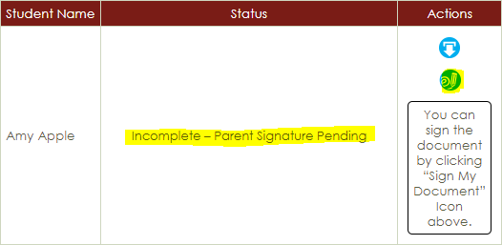
IMPORTANT:
If the parent link has expired, or the parent didn’t receive the email, the student needs to log in to the WASFA home page and re-invite their parent. Make sure the correct email address is entered.

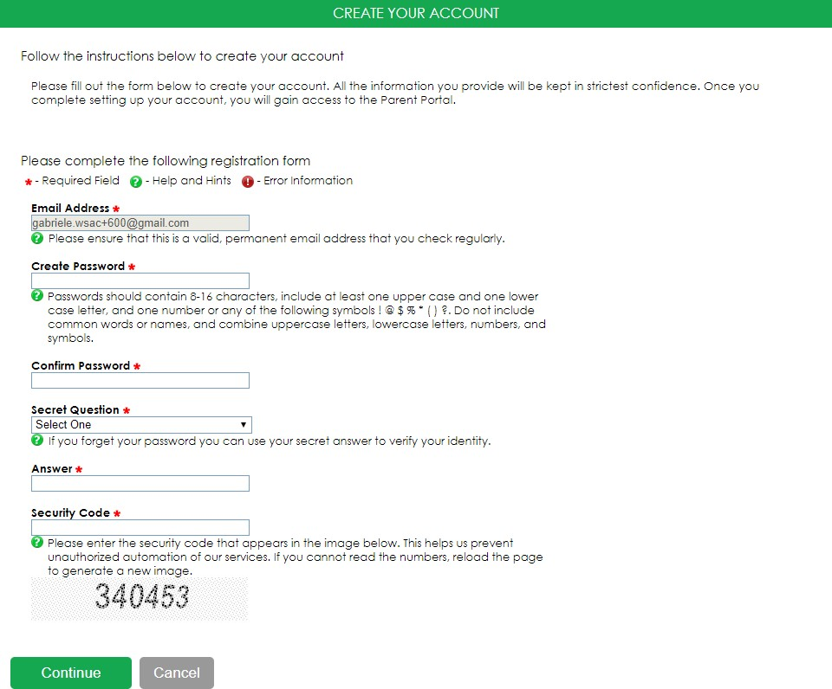
Parent Signature Process (3 of 7)

Once the parent clicks on the Parent Portal link in the email, it will bring them to this page to create an account. Their email address will already be pre-filled in the box.

Please find a safe place to secure your password and answer to the secret question. Click on Continue once you have filled out all the requested information.

After the parent clicks on Continue, the parent will need to enter their birthdate and last 4 digits of Social Security Number (SSN), or four zeroes if no SSN, to verify their identity. The parent will then be prompted to enter the student’s birthdate. Click Register to continue.
Parent Signature
Process (4 of 7)
You will know that you are in the parent portal because the band
color is red instead of green

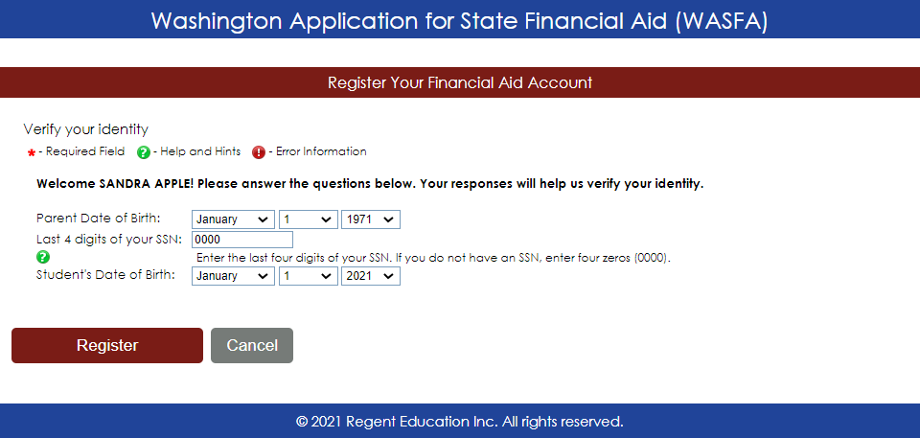IMPORTANT:
The birthdate and those 4 SSN digits MUST match exactly what the student entered on their application, or the parent will not be able to create an account and sign the application.

The WASFA application home page will display any applications that are pending the parent’s signature. Click on the “Sign an application” icon to open the application.
Parent Signature Process (5 of 7)

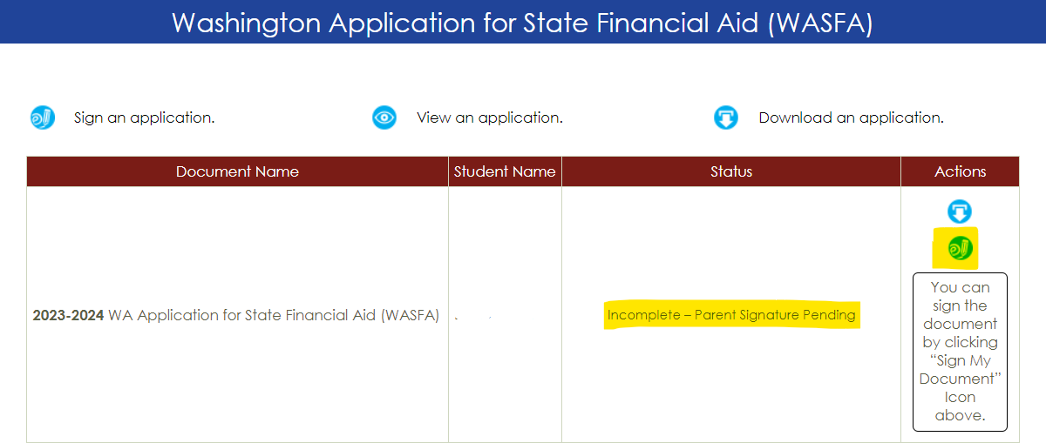

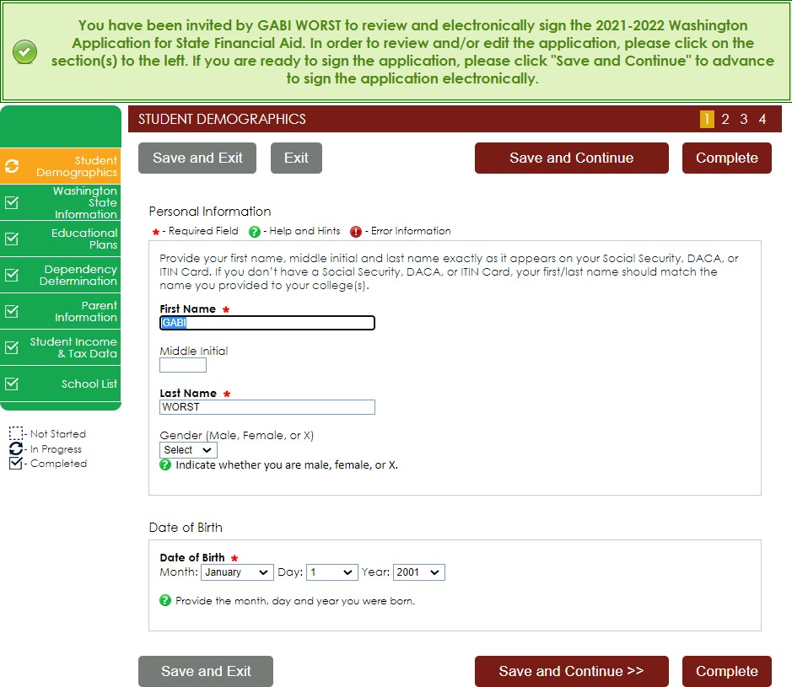
Parent Signature Process (6 of 7)

The parent should review the information the student has entered and click on Save and Continue on each page, all the way to the end of the application.

If any changes need to be made, the parent may make those changes at this time.

The parent is going to repeat the same steps the student did to complete the electronic signature process.
Parent Signature Process (7 of 7)

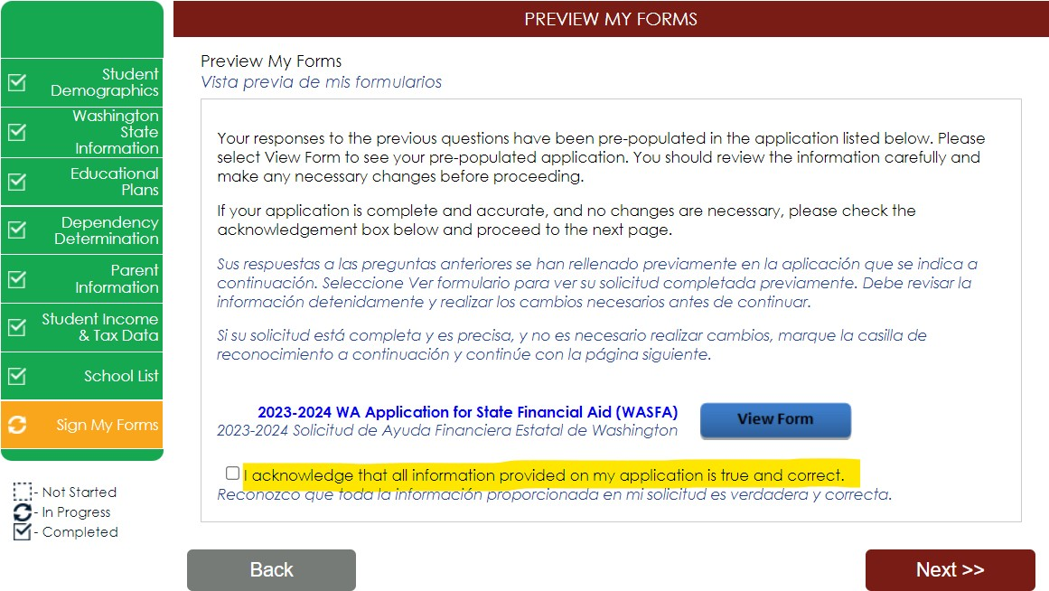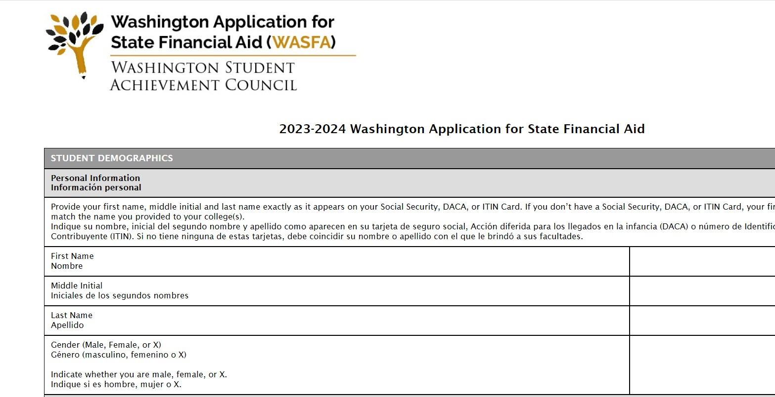Sign My Forms – The Preview My Forms section is an opportunity to review all the answers by clicking on the View Form button. You MUST open and preview this form before you can acknowledge that the information is true and correct.
The form will open in a separate tab, once you have viewed it you can close the tab, check the box acknowledging your information is true and correct, and click on the Next button.
Review answers carefully and make
corrections prior to signing.

Parent Electronic Signature

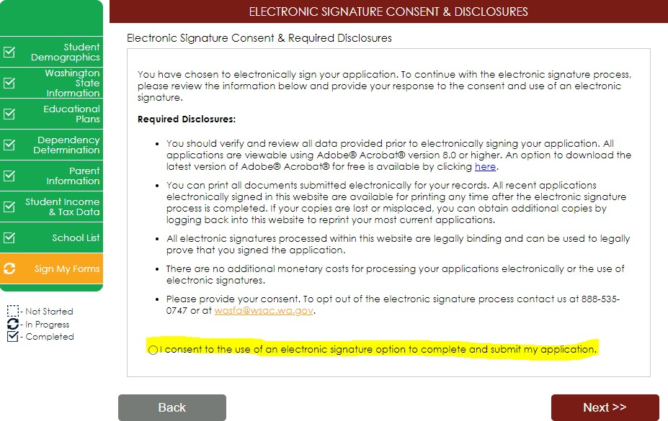Sign My Forms – Electronic Signature Consent & Disclosures. Please read disclosures and select the “I consent to the use of an electronic signature option to complete and submit my application.” Then click on the Next button.

Parent Electronic Signature

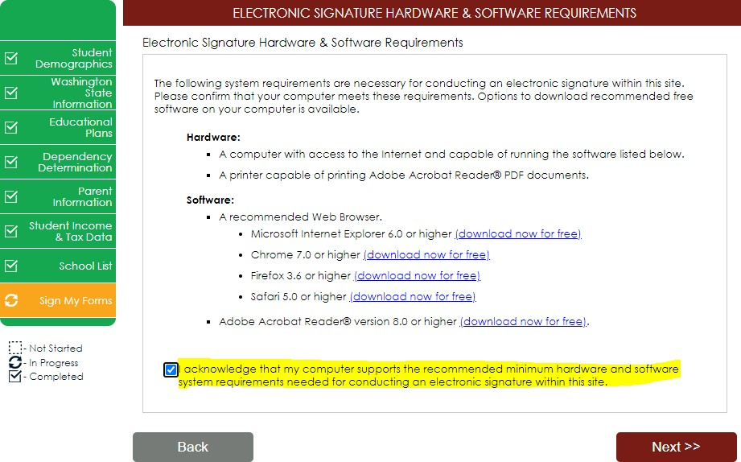Sign My Forms – Electronic Signature Hardware & Software Requirements. Please read the system requirements and select the “I acknowledge that my computer supports the recommended minimum hardware and software system requirements needed for conducting an electronic signature within this site.” Then click on the Next button.

Parent Electronic Signature

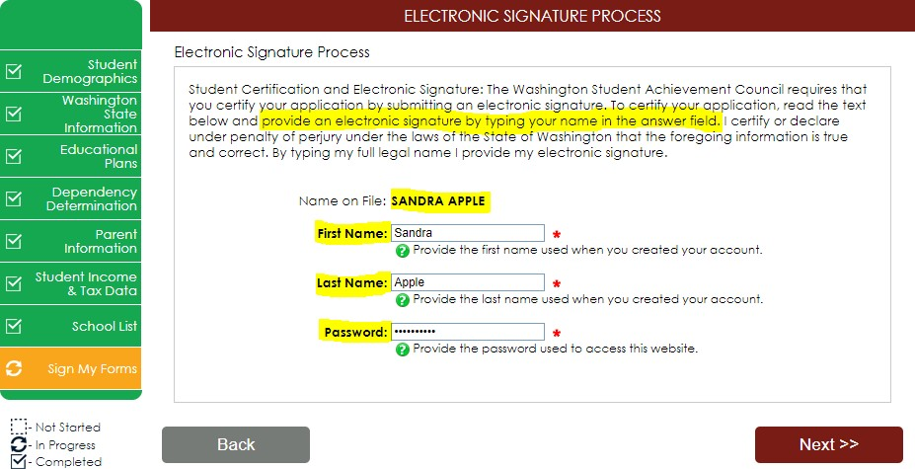Sign My Forms – Electronic Signature Process. Please read the disclosures, which state that you are certifying the information you provided is true and correct.
Name and password information entered must be exactly the same as when you created your account. Then click on the Next button.

The WASFA application home page should now show the application status as “Submitted” and the date it was completed. You will not receive an email confirmation.
Parent Signature Complete

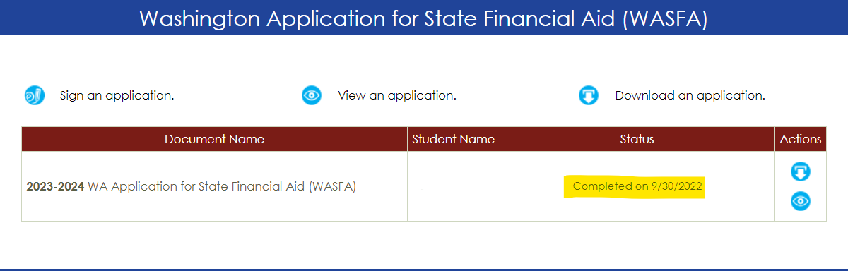

Information & Tips for
After you Complete your Application

- Once your application is complete, within 24 hours your information will be made available to all prospective schools listed in your application.
- The financial aid offices will use the information submitted in your WASFA to prepare a financial aid offer with the amount and types of state aid you are eligible for.
- If you have any more questions about the financial aid award process, timeline, or your EFC, please check with your school’s financial aid office. Only your school can provide you with this information.

Information & Tips for
After you Complete your Application

- If you need to make any changes to your application once you have submitted it, please log back into the Student WASFA Home Page (see Returning Users instructions) and follow these steps:
  - Select the application that needs to be updated
  - Make the necessary changes
  - Save your application
  - Electronically re-sign your application, and if a parent previously signed your application, you will need to invite them to re-sign the application.

You will not be able to edit your application and your schools will not be able to see your updated application until the parent signature is complete.

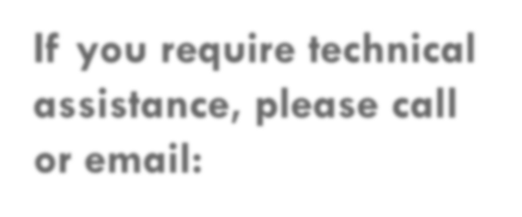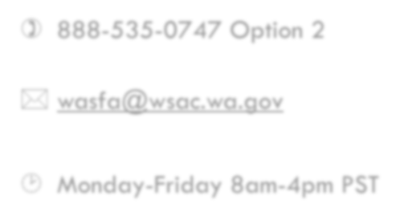
If you require technical assistance, please call or email:
 888-535-0747 Option 2
 wasfa@wsac.wa.gov
 Monday-Friday 8am-4pm PST

