How to Complete the 2023-24 WASFA

Washington Application for State Financial Aid

wsac.wa.gov/wasfa

Updated 12/28/2023

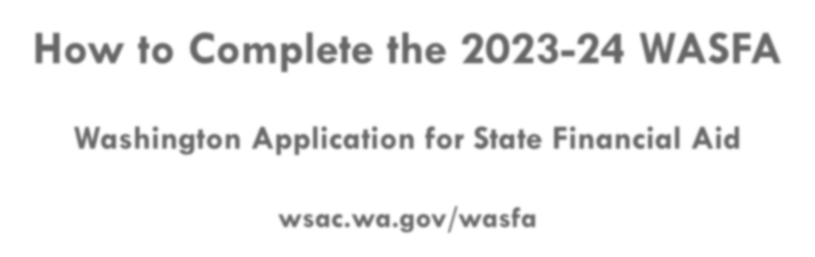

Overview (1 of 3)

WASFA Privacy Statement
The Washington Student Achievement Council (WSAC) administers state financial aid including the Washington College Grant, the College Bound Scholarship, and the Washington Application for State Financial Aid, or WASFA, for undocumented individuals. The Council is committed to providing opportunities and support to ensure every Washington student is able to pursue education beyond high school.

Regarding concerns that students, parents, and other partners may have about the confidentiality of information submitted on the WASFA, the purpose of the application is to provide eligibility information to colleges and universities in Washington that offer the Washington College Grant and the College Bound Scholarship. WSAC shares application information with campuses listed by the student so those schools may determine eligibility for resident tuition and financial aid. Campuses are not permitted to use the information for other purposes or share the data with other parties.

WSAC is committed to protecting the confidentiality of the information and privacy of students and families. Washington is a
state committed to providing opportunities to students and protecting the rights of families.

Overview (2 of 3)

State Financial Aid for Undocumented Students and Other Select Applicants
The Washington Application for State Financial Aid (WASFA) is for people who don’t file a federal FAFSA application. People who complete a WASFA are applying for state aid only. Please do not complete a WASFA if you have already completed a FAFSA.
There are various reasons to complete a WASFA instead of a FAFSA:
- Immigration status, or student is undocumented
- Undocumented parents or family members do not wish to file a FAFSA
- Defaulted federal loans
- Repayments owed on federal grants

Overview (3 of 3)

The WASFA application can be found at wsac.wa.gov/wasfa. The following instructions will aid you in successfully completing the WASFA.
- New users completing the WASFA questionnaire for the first time will be asked a series of questions to determine if the WASFA is the appropriate financial aid application to complete. If it is, a link to the WASFA application is provided. If not, a link to the FAFSA is provided.
- Returning users wanting to create a new application, or to make corrections to an existing application, please select the Returning User button and select the appropriate link that matches the Returning User scenario.
Please do not create a new account. Contact us via email at: wasfa@wsac.wa.gov if you are

unable to access your account.

Select New User or Returning User.
New User or Returning User?
New Users will be asked a series of eligibility questions to ensure the WASFA is the correct application before bringing the User to the login page to create a new account.

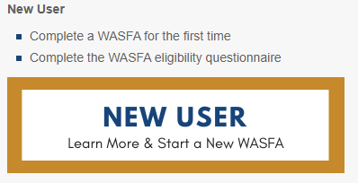
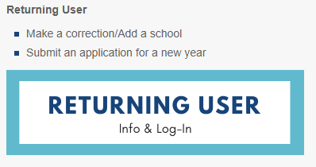

Returning User Screen

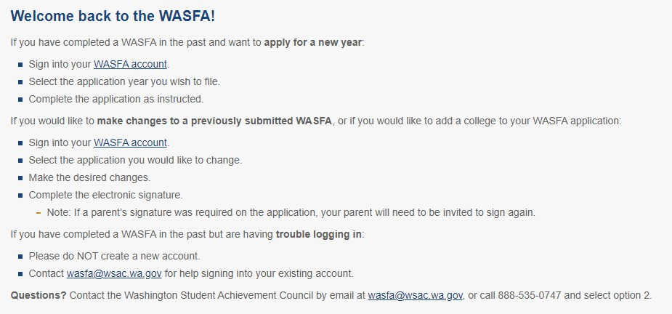

Choose which Returning User scenario applies to you.

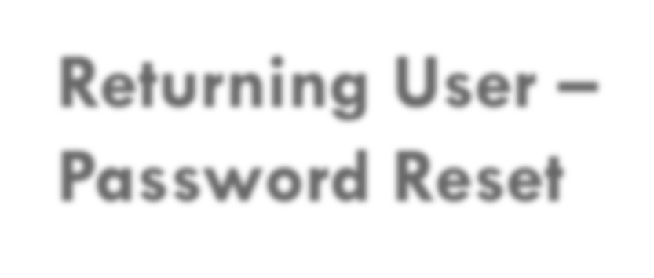
Returning User –
Password Reset
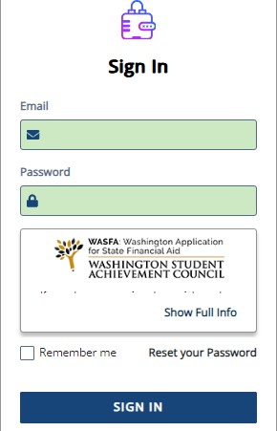
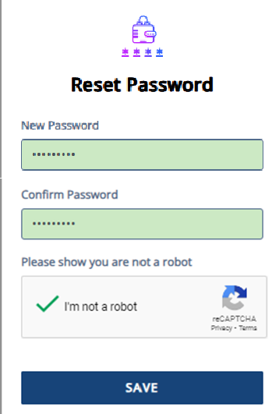
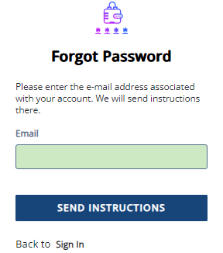
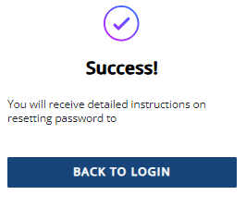
If you have forgotten your PASSWORD, please click on the “Reset your password” link from the sign in page. You will be prompted to enter the email address you used when you registered.
email@gmail.com
You will receive an email with a password reset link. Click the link to be directed to create a new password. Once you click save, you will be redirected to log in with your new password.

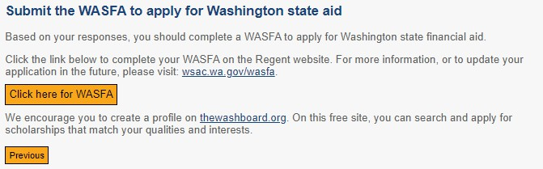
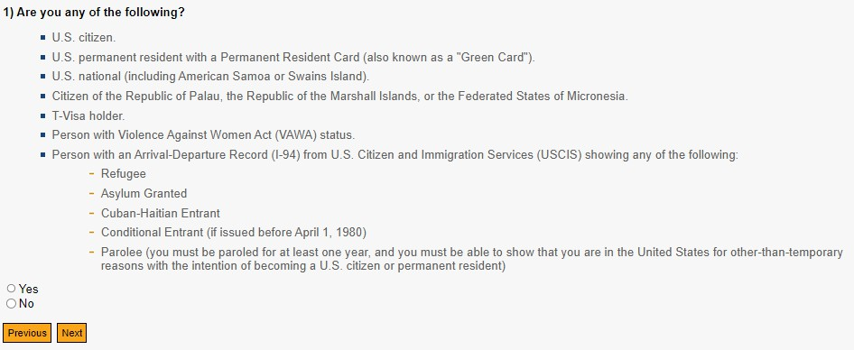
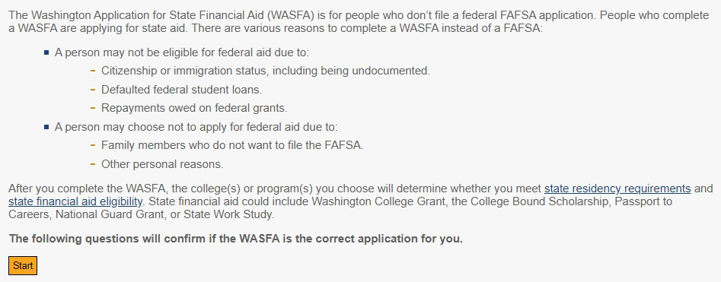
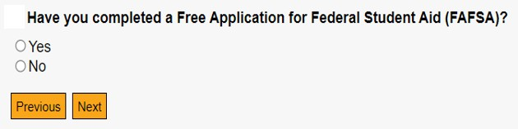
Eligibility Questions for New Users

Prepare to Start the WASFA

What you will need to complete the WASFA:

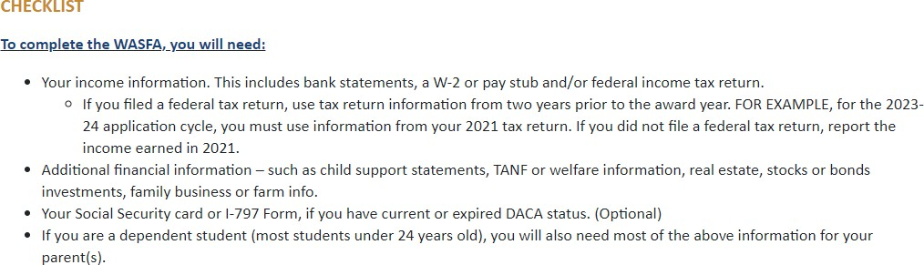

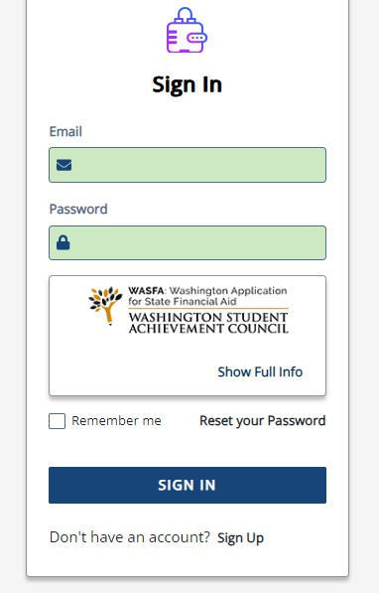
Create New Account – Step 1

To begin, create an account by selecting the Sign Up button on the screen shown to the right.

Create New Account – Step 2

Answer another FAFSA Eligibility Question. If eligible to complete a FAFSA, the applicant will be
redirected to the FAFSA site. If not, the applicant will continue to fill out WASFA application.
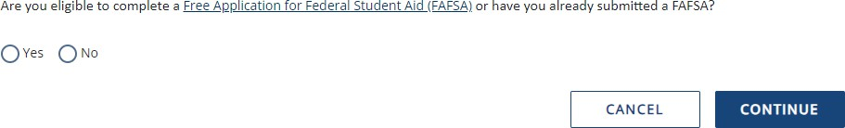

Note: If you have already completed a FAFSA, please do not also complete a WASFA. Your school will be
able to determine your eligibility with the information submitted on your FAFSA.

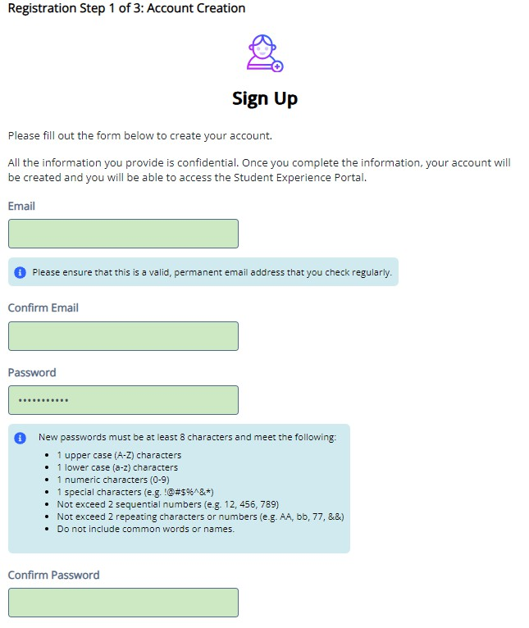
Registration Step 1– Account Creation

Register for new WASFA Account

Please use an email you will be able to check regularly. Ex: a personal Gmail and not a school email.

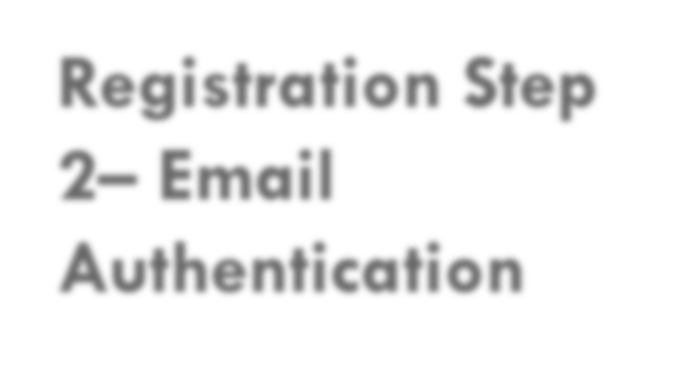
Registration Step 2– Email Authentication
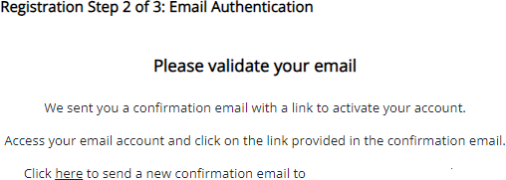
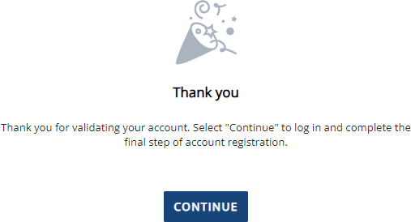
Activate your student account by clicking on the authentication link that is sent to the email provided in step 1.

student@gmail.com

After clicking the link in step 2, you will be redirected to the WASFA site and will receive the following notification letting you know your account has been successfully activated.

Click “continue” button to proceed.

Please note: You will not be able to log in or access your account until
your email has been validated

Registration Step 3 – Account Validation

Register for new WASFA account
Please double check the spelling of your
name AND your Date of Birth.

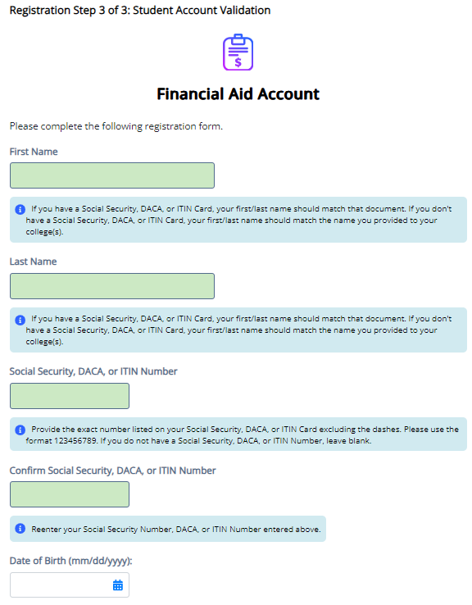

What numbers do I use?

- If you have a SSN, DACA, or ITIN, enter it here. If you do not, leave blank.

- If you have never applied before and do not have a SSN, DACA, or ITIN nor a WASFA ID, leave all SSN, DACA, or ITIN and WASFA
ID fields blank.

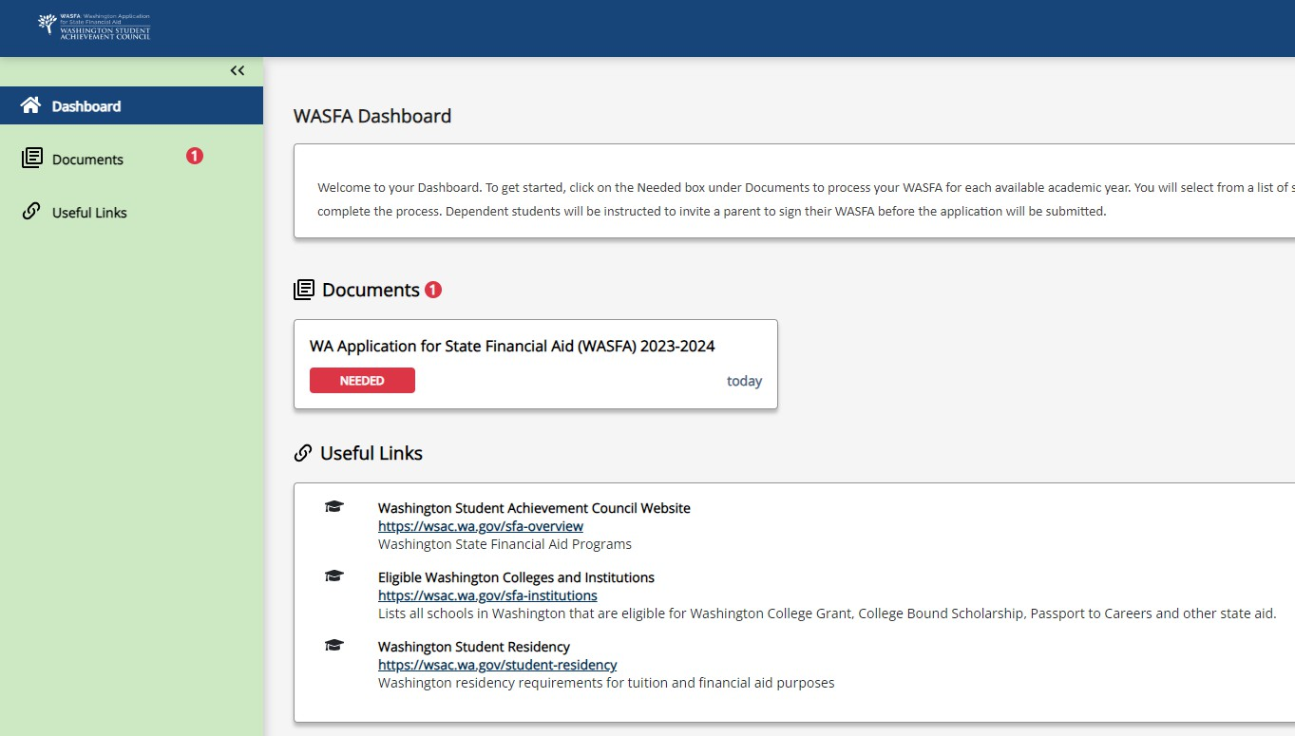
WASFA Dashboard

Once you have logged into your account, this will be your WASFA home page/Dashboard.

Applications needed, in progress, or previously submitted can be accessed from the Dashboard page or on the Documents page

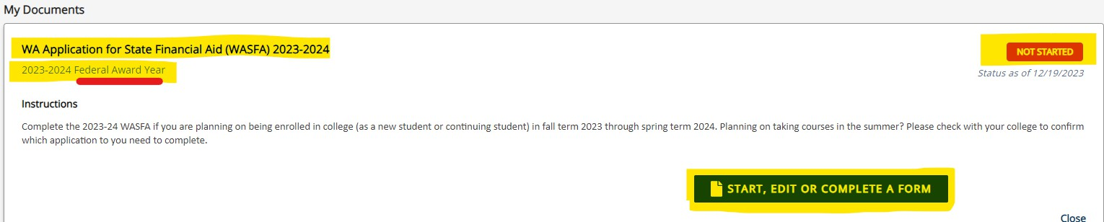
Click on:
Starting the WASFA

for the application year you want to start.
There may be times where there are multiple application years open at a time. Be sure to select the year for which you will be attending college. For example, if you plan on attending school in the Spring of 2023, you would choose the 2023-2024 application year.

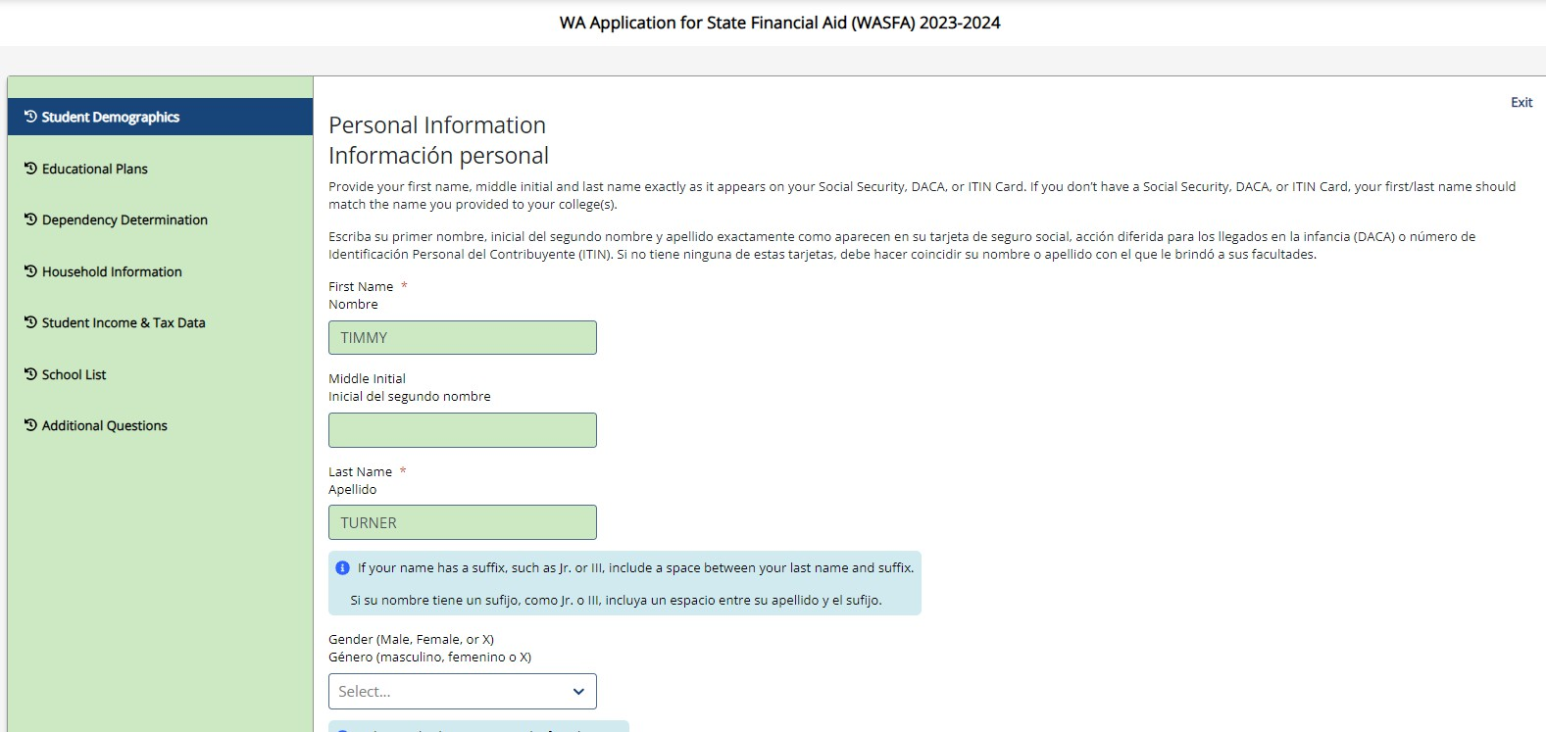
Application in Progress

Upon clicking the “Start, edit, or complete an application”, you will begin the application process.

Answer the questions and click on the “Next” button to continue moving through the application process.

*To Save Progress: Click “Exit” and then “yes” (see on top right corner)

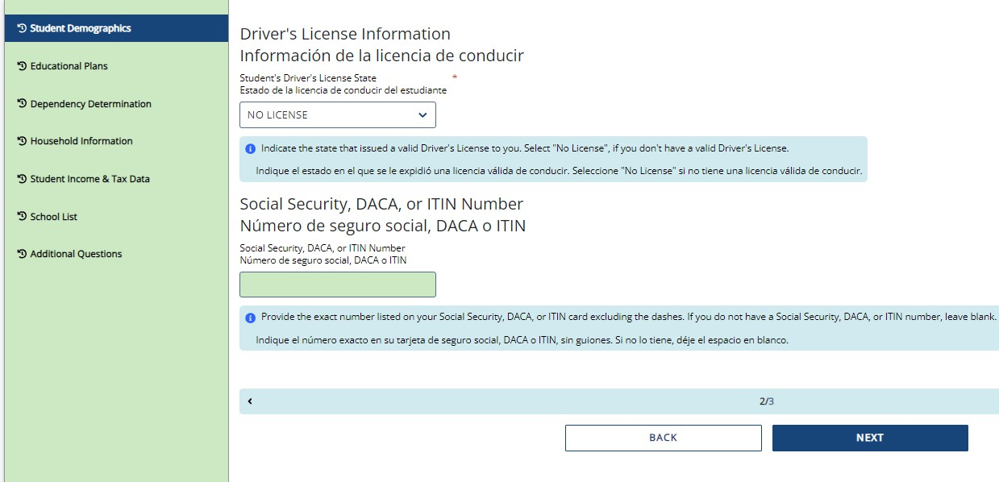
Application in Progress (1 of 2)

As you move through the application process, the green menu on the left side will display the section you are in, and the numbers in the bottom blue bar will display how many parts are in that specific section, and what page you are on. Click “Next” to continue.

*To Save Progress: Click “Exit” on top
right corner and then “yes”.

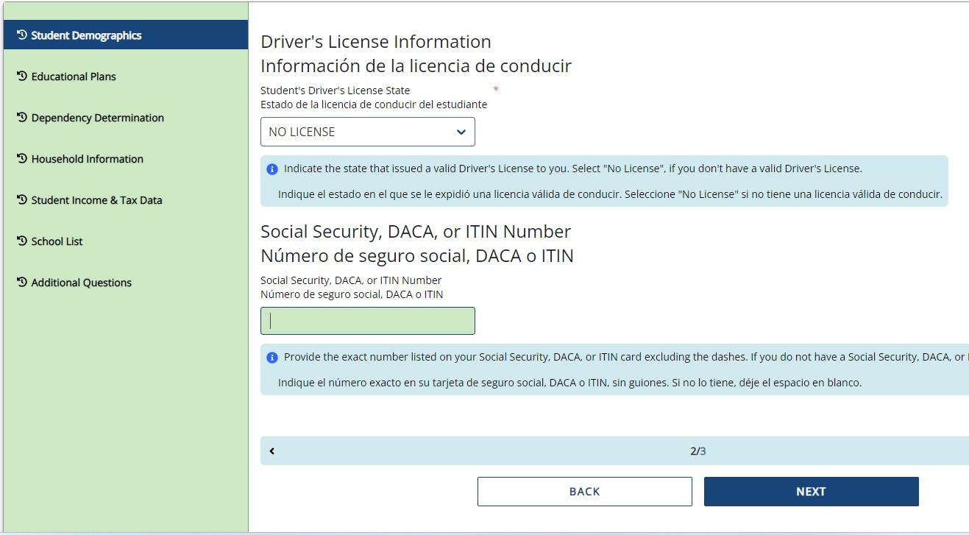
Application in Progress (2 of 2)

The following instructions will not show a screen shot for every question. However, we will highlight a few of the areas that are asked about most often.

The section and page number within the section we are discussing is circled in red in the left green menu and bottom blue bar.

New Residency Information

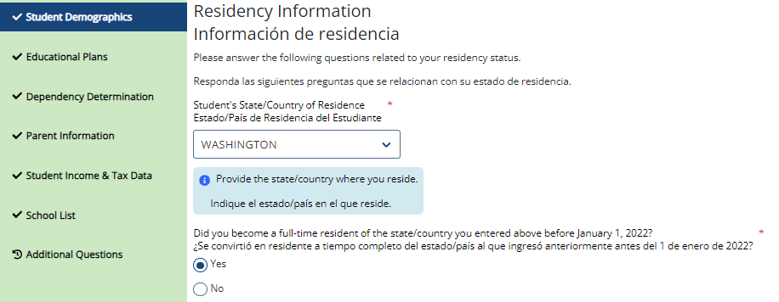
Answer all the residency questions carefully and accurately. The residency law changed on July 25, 2021, making it easier for more students to qualify.

*More information on the new
residency law on slides 39-40

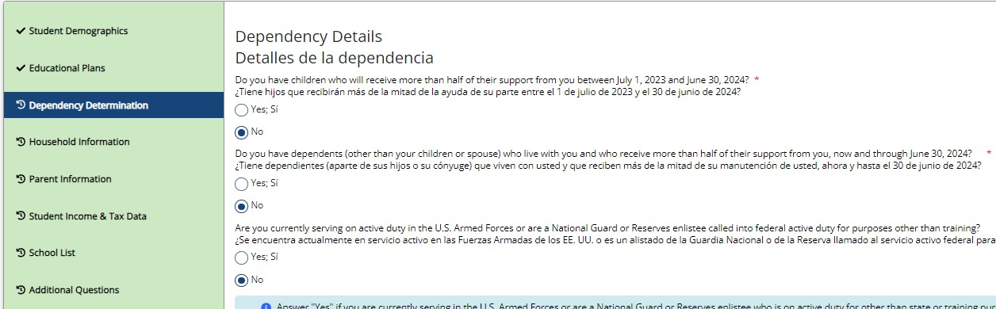
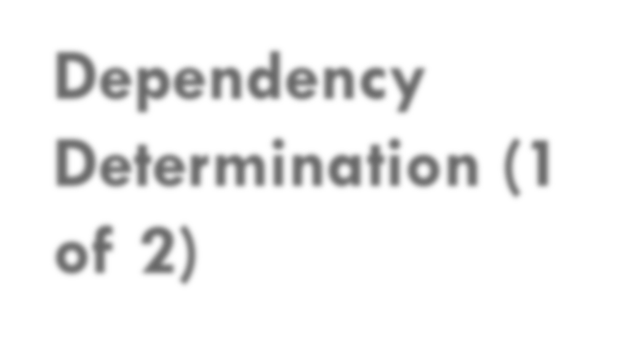
Dependency Determination (1
of 2)
In the Dependency Determination section, answer all the questions carefully and accurately.
This section determines if you are considered a “dependent” student or an “independent” student.
Please read the descriptions carefully. Answering “Yes” to any of these questions will mark you as an “independent” student and you will not be asked to enter any parent information or require a parent signature.

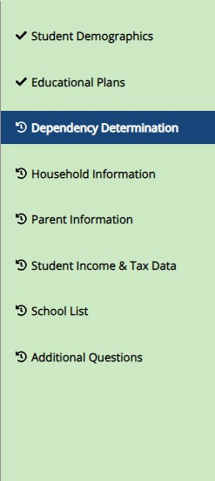
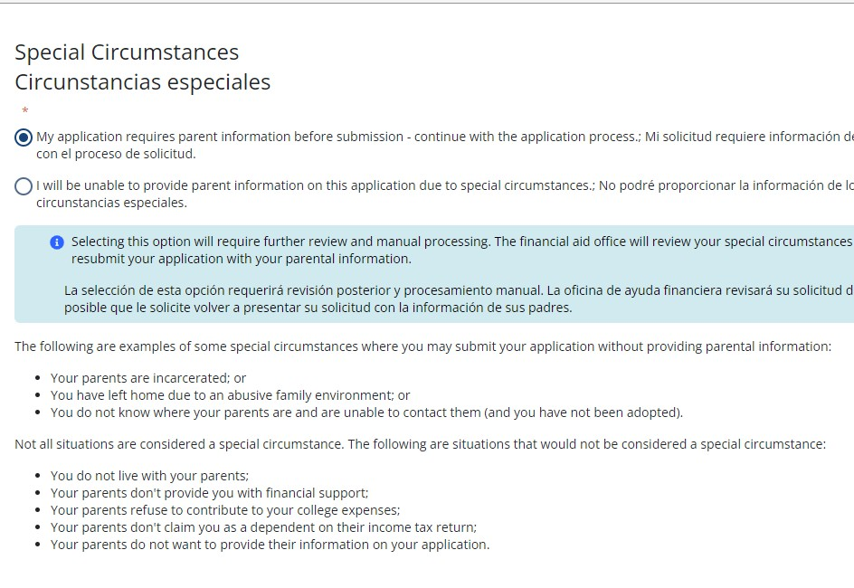
Dependency Determination (2 of 2)

SPECIAL CIRCUMSTANCES
If you are determined to be a “dependent” student, you will be required to answer questions about your parents.
Most people will fall into this category.
You may be able to submit your application without parent information under special circumstances if you meet outlined criteria. Your financial aid office will either approve or request for you to submit your parent information.
Note: Claiming special circumstances when you do not qualify may delay the processing of your application.

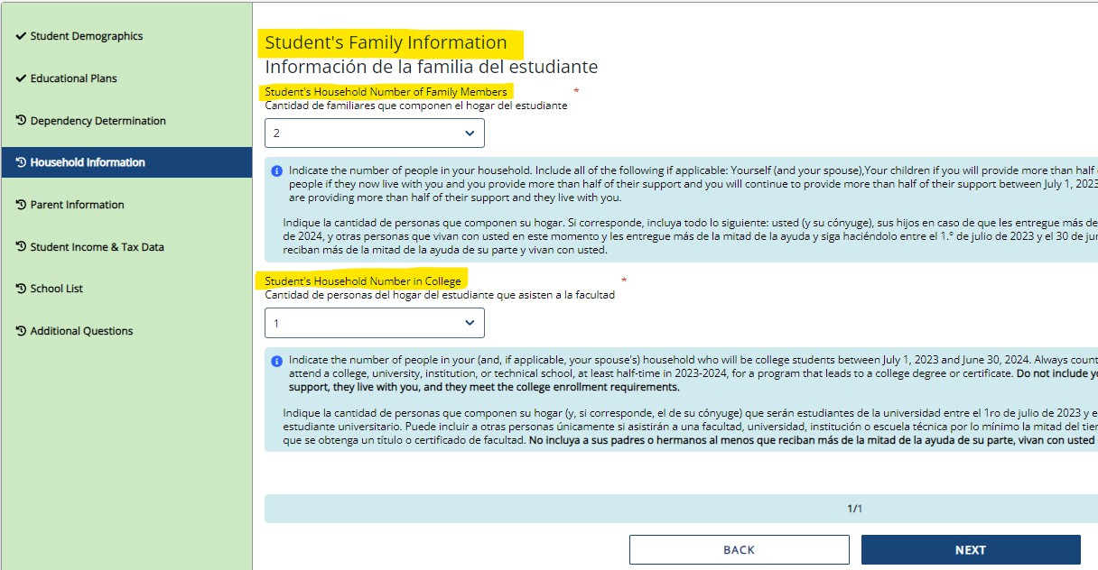
Family Size Information

On Student’s Family Information answer all questions as they relate to only the student and who the student financially supports. “Student’s Household Number of Family

Members” should only count dependents the student financially supports by themselves. Same for number in college.
Example: If a student is unmarried with no children of their own, and is not financially responsible for anyone else, the student’s household number is 1 and the student’s number in college is 1. Other family members, such as parents and siblings, will be captured in the Parent’s Information section.

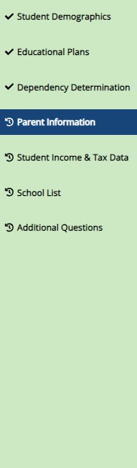
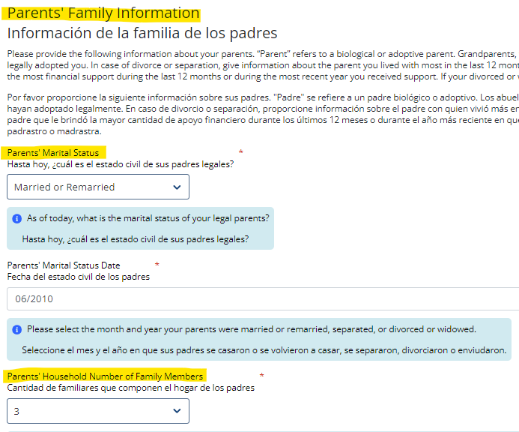
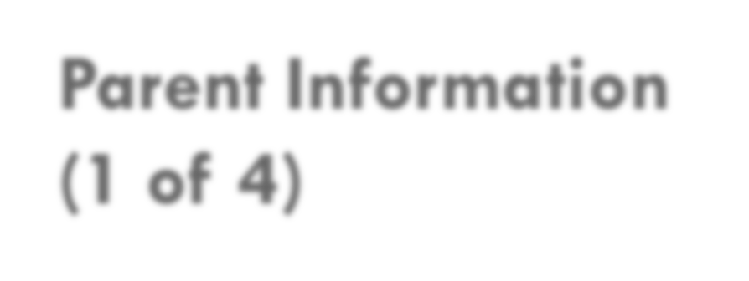
Parent Information (1 of 4)

For Parent Information answer all questions as they relate to the parent(s) and all others they are responsible for supporting financially(including you).

Example: If a student has 2 siblings also in college and the parent has never been married, then the parent household number is 4, and the parent number in college is 3.

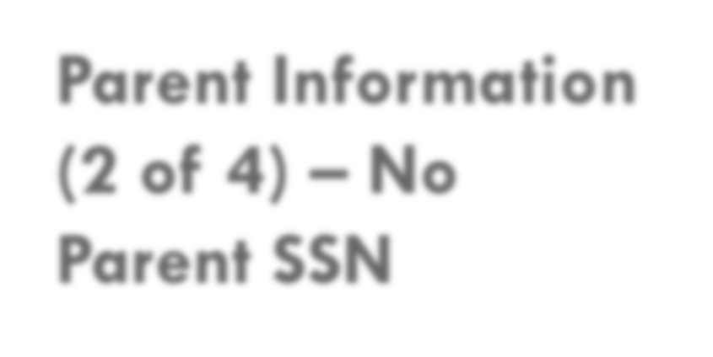
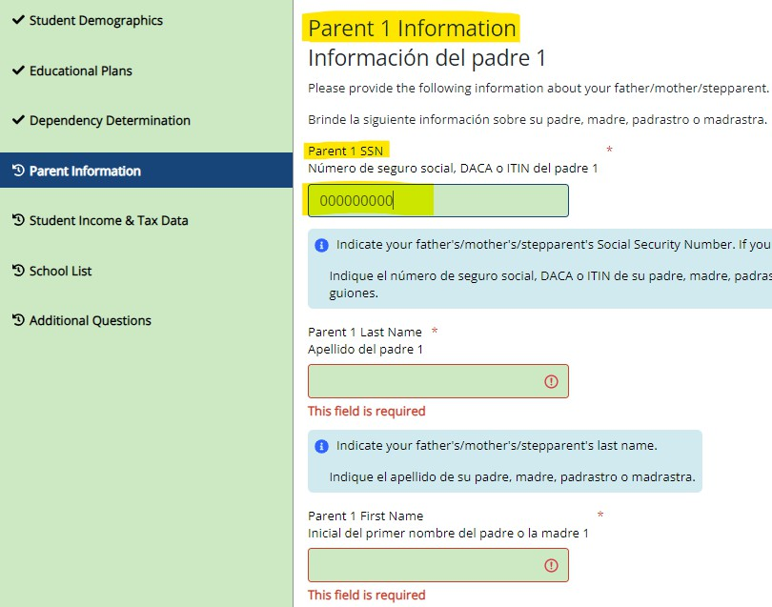
Parent Information
(2 of 4) – No Parent SSN
If your parent/s do not have a Social Security Number enter all zeroes (do not put in random
numbers).
IMPORTANT:
Parent/s do not need a Social Security Number for their child to apply for financial aid.

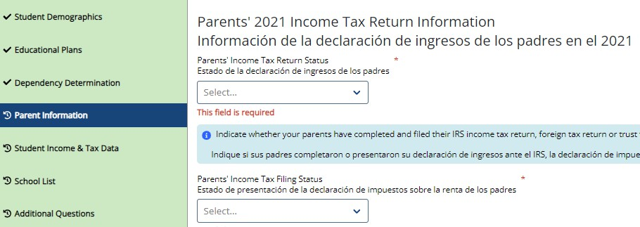
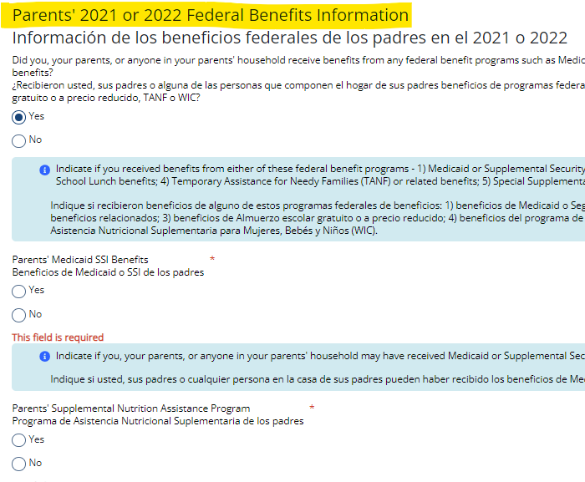
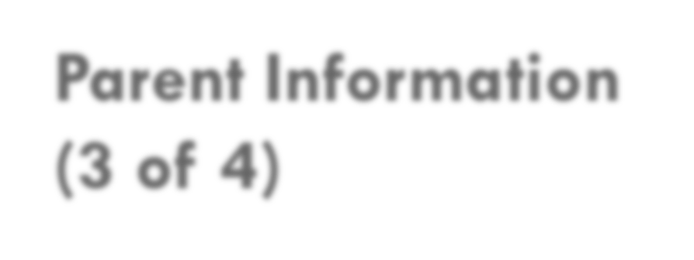
Parent Information (3 of 4)

For Parent Information answer all questions as they relate to the parent(s).
If the family receives federal benefits such as Medicaid, SSI, food assistance, free or reduced-price school lunch or any other assistance, those numbers will be captured on this page under the
Parents’ 2021 or 2022 Federal
Benefits Information.

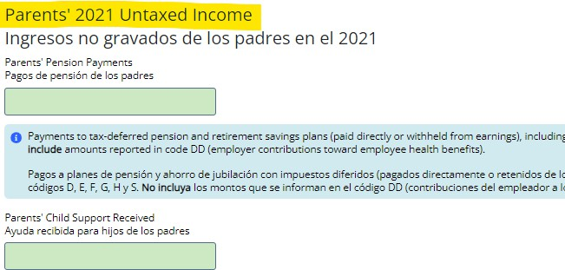
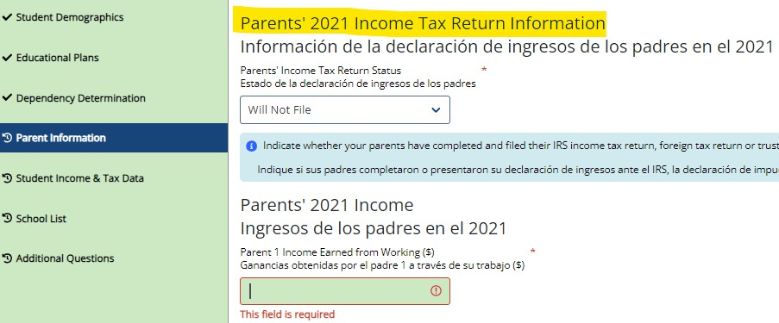
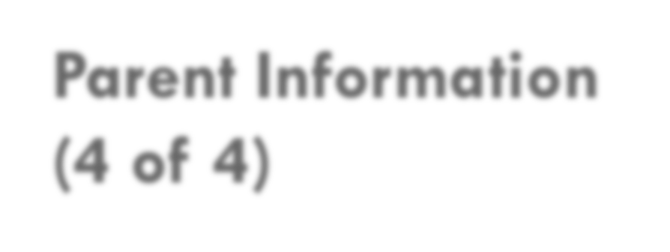
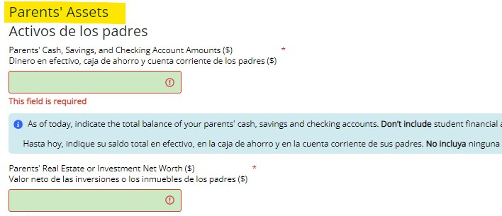
Parent Information (4 of 4)

Parents’ and students, are not required to file taxes to receive state aid. However, if income reported is $50,000 and over, questions regarding assets and untaxed income will need to be estimated using bank statements, paystubs, etc.

Student Income and Tax Data

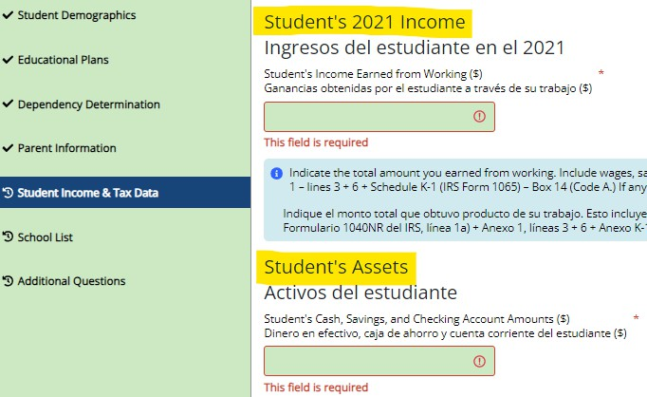
On Student Income & Tax Data answer all questions as they relate to only the student, including additional income and federal benefits. If the family receives food assistance or other assistance, those numbers will be captured in the parent section of the application.

School Selection
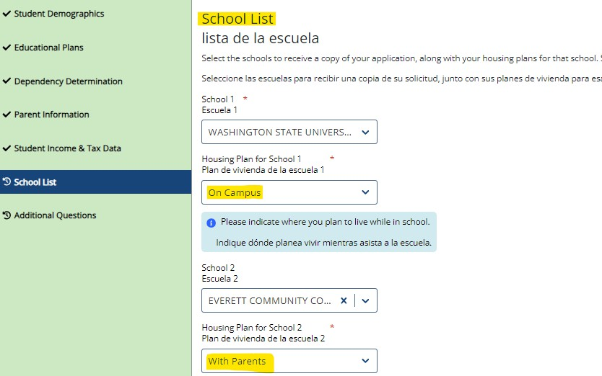
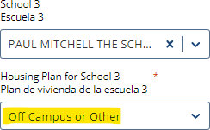
Select the schools you are considering attending, even if you haven’t applied or been accepted. You may choose up to 10 schools. This will allow you to get your financial aid application submitted to assist in meeting any financial aid priority deadlines schools might have in place.

If you want to live on campus, or don’t know what your housing plan will be yet, select “On
Campus”

If you don’t know what your housing plan will be, select “On Campus.” If you change your mind later, let the financial aid office know.

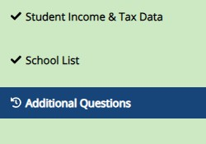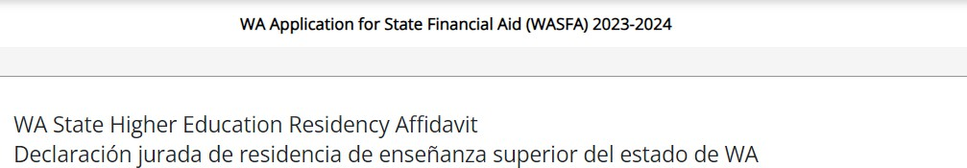

Residency Information
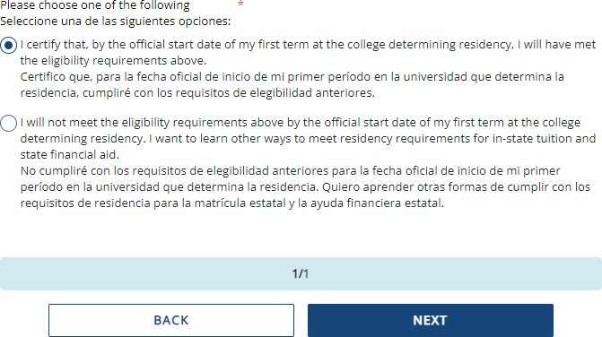
Answer all the residency questions carefully and accurately. The residency law changed on July 25, 2021, making it easier for more students to qualify.
In this section, you are certifying that you meet the requirements shown in the: “WA State Higher Education Residency
Affidavit” and “Certification Regarding Permanent Residency Application and Related Responsibilities.” Please read the descriptions carefully. (Sample affidavit on next page)
Choosing “I will not meet” will open questions
for you to answer regarding DACA.

WA State Higher Education Residency Affidavit Sample

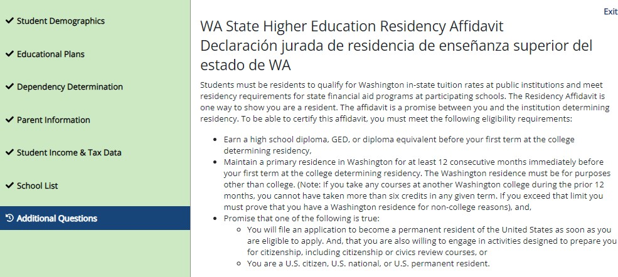

Residency Affidavit Update

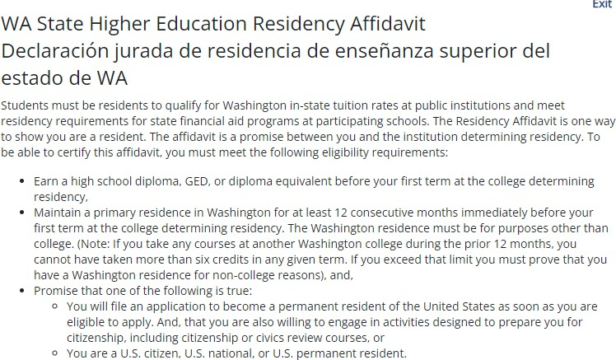
NEW REQUIREMENT AS
OF JUNE 6, 2022:
The Washington residence must be for purposes other than college. reasons.

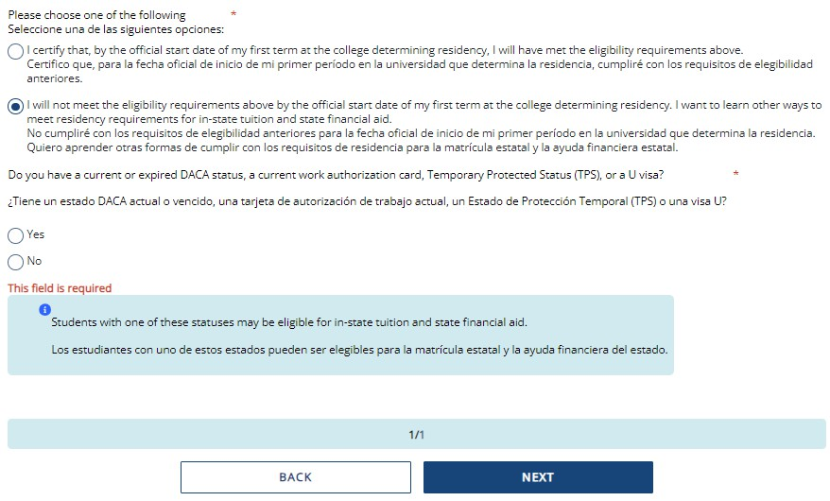
Residency Information

On Residency Information answer all the
residency questions carefully and accurately.
If you answer “I will not meet the eligibility requirements” in this section, you will need to answer the DACA question, then click Save and Continue.
If you answer “No” to the DACA question, continue filling out the WASFA to the end. Your school will determine if you meet eligibility based on the information you provide.
Note: You will not get the DACA question if you answered, “I certify that, by the official start date of my first term at the college determining residency, I will have met the eligibility requirements above.”

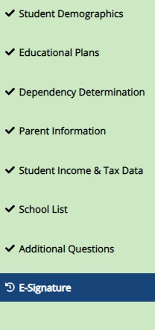
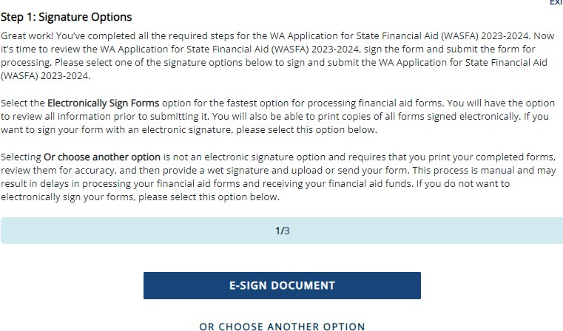
Signature Section- Step 1

Once all required sections have been completed, you will be directed to the signature section for the final step in the application process.

Click E-Sign Document to continue.
Important: The “Or Choose Another Option”, will have longer processing times and potential delays in determining
your financial aid eligibility. Please do not choose that option without contacting WASFA@wsac.wa.gov first.

Signature Section- Step 2
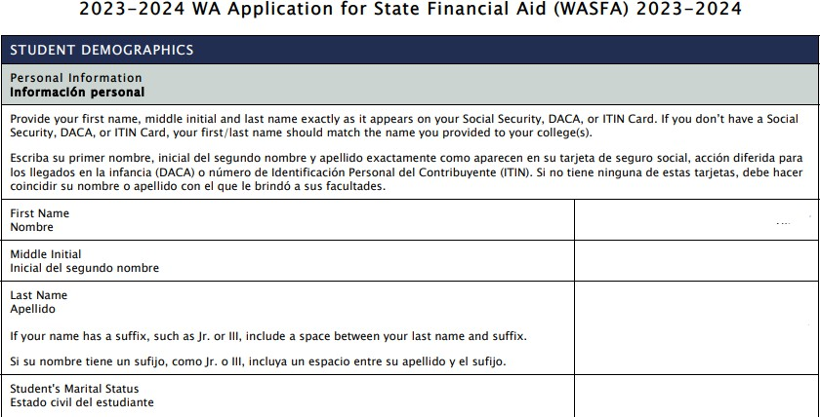
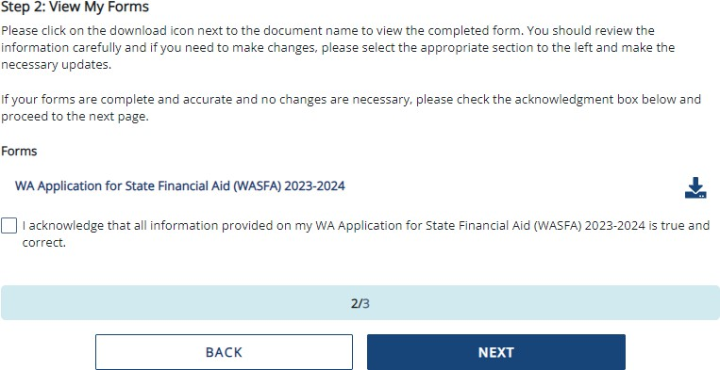
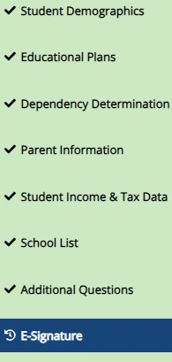
E-Signature – The View My Forms section is an opportunity to download your application and review all your answers by clicking on the icon. You MUST open and preview the downloaded form before you can acknowledge that the information is true and correct. Please review answers carefully and make any needed corrections before signing.
The form will open in a separate tab. Once you have viewed it you can close the tab, check the box acknowledging your information is true and correct, then click Next.

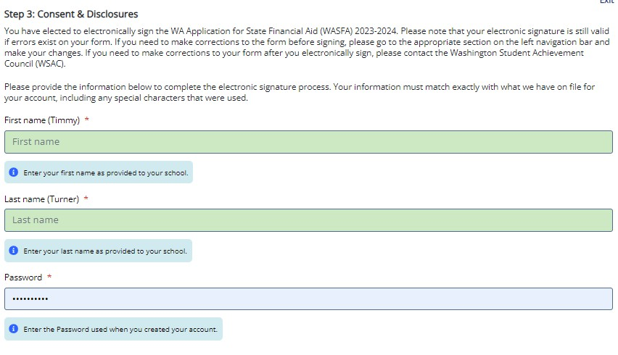
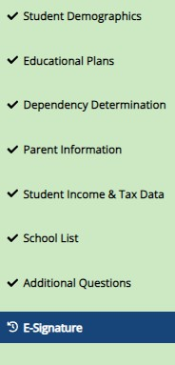
Electronic Signature Page Sample

After viewing your forms, you will be directed to the last page of the application.

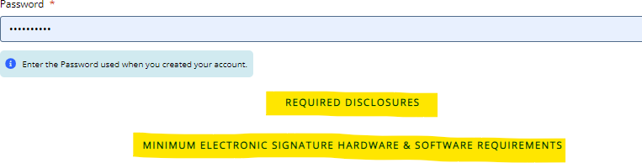
E-Signature - Consent & Disclosures

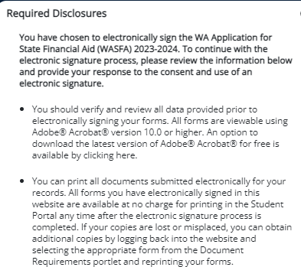
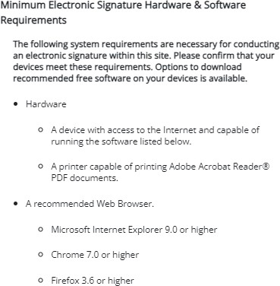
Electronic Signature Consent
& Disclosures.
Please click on and read the disclosures you are certifying when electronically signing your application that state you are certifying the information you provided is true and correct.

Signature Section- Step 3
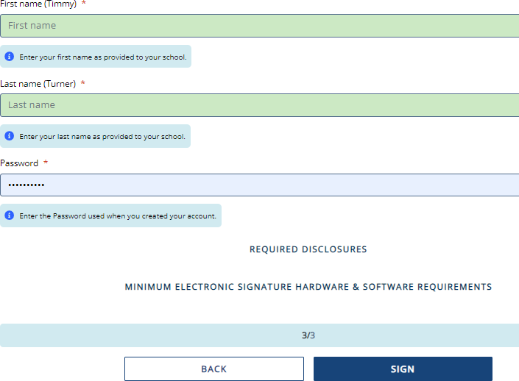
Sign My Forms – Electronic
Signature Process.
Name and password information entered must be exactly the same as when you created your student account.
Then click

Application Complete / Incomplete

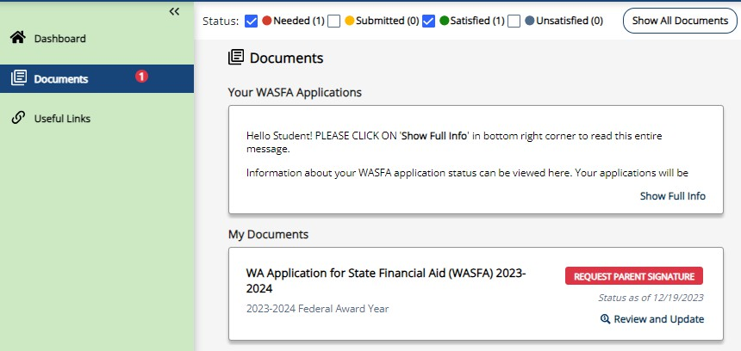
Once you complete the electronic signature section, you will be redirected to the WASFA Documents page. If you are an independent student, your application is complete and will be sent to your prospective schools within 24 hours. You will receive an email confirmation.

If you are a dependent student, you will need to ask your parents to electronically sign your application. To invite a parent, click on the
button circled on the right.

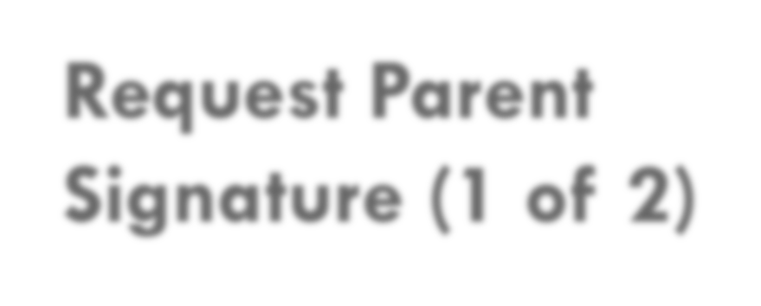

Request Parent Signature (1 of 2)

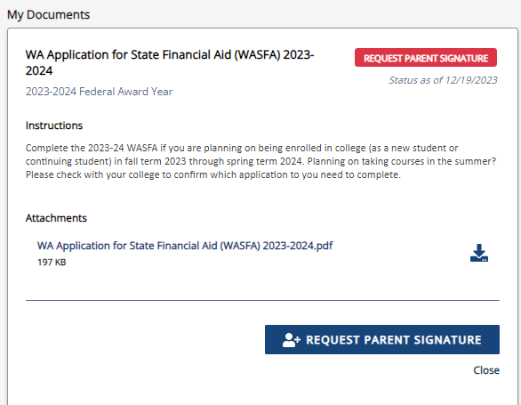
The “My Documents” section will then expand. Click the Request Parent Signature button and invite your parent/contributor to review and sign your application.

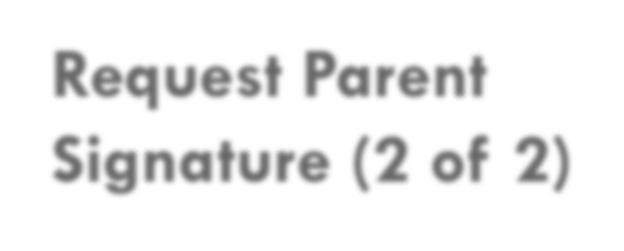
Request Parent Signature (2 of 2)
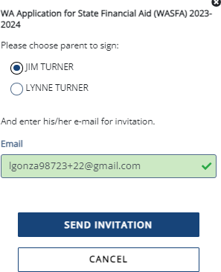
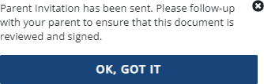
Once you click on the “Request Parent Signature” button in the Documents section, it will bring up your parent choices.
parent@gmail.com

Choose only one parent and make sure their email address is correct. If necessary, correct or update the email address, then click on the button.
IMPORTANT:
The parent email address cannot be the same email address the student used to create the account, and the parent must use this email address to create their parent account to be able to sign and submit the student’s application.
You will then receive a notification letting you know the invitation email has been sent.

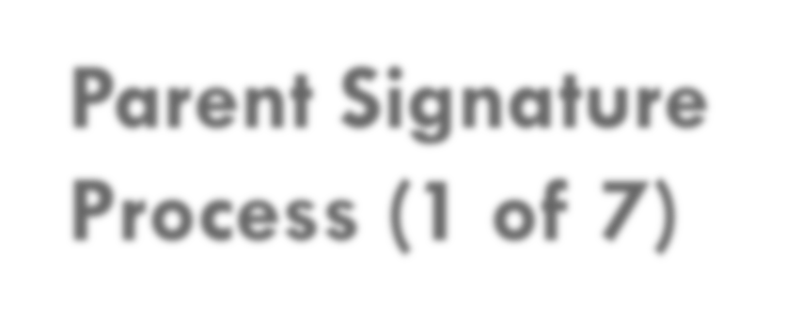
Parent Signature Process (1 of 7)

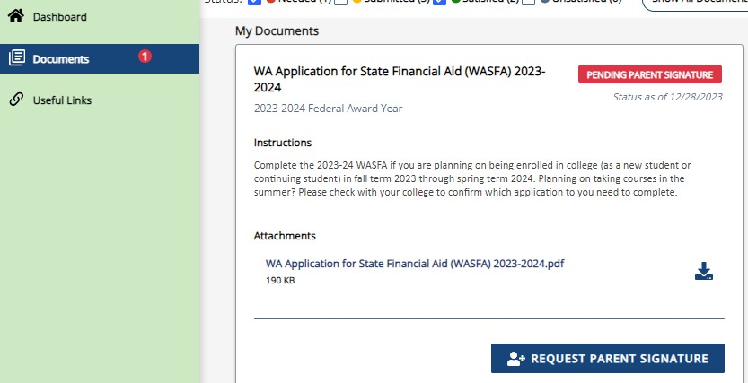
Once the parent invitation is sent, you will be redirected back to the WASFA Documents page. The application status will display
until your parent signs.
Logout of your student account. Your parent will receive an email with a link to create their own account and to electronically sign your application. This link expires in 72 hours.
If your link has expired, log back into your student account and send a new invitation. Once your parent has electronically signed your application, your application will say completed.

Note: You must be logged out of your student account if your parent is
using the same device/computer to sign the application.

Parent Signature Process (2 of 7)

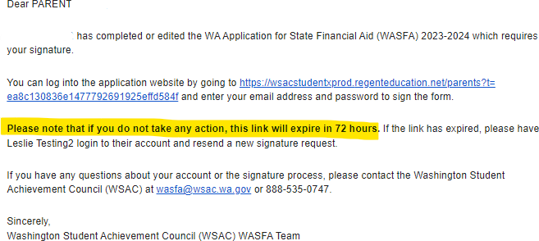
The parent you selected will receive an email like the one shown on the right. The parent needs to click on the link provided to bring them to the Parent Portal. Here they will create their own account using the same email address the Signature Request link was sent to. The link is only valid for 72 hours.

Student A

IMPORTANT:
If the parent link has expired, or the parent didn’t receive the email, the student needs to log in to the WASFA home page and re-invite their parent. Make sure the correct email address is entered.

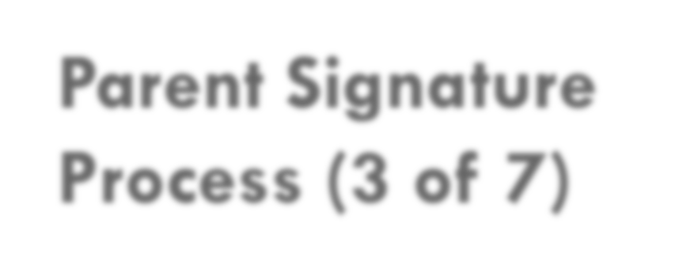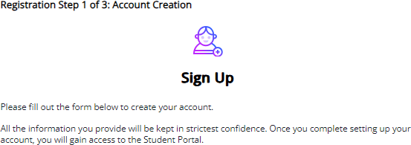
Parent Signature Process (3 of 7)

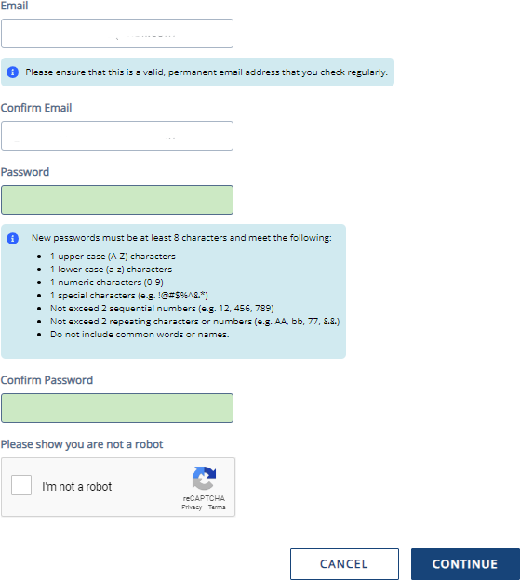
Once the parent clicks on the parent portal link in the email, it will bring them to this page to create an account. Their email address will already be pre-filled in the box.
parent@gmail.com
parent@gmail.com

Please find a safe place to secure your password. Click Continue once you have created a password.

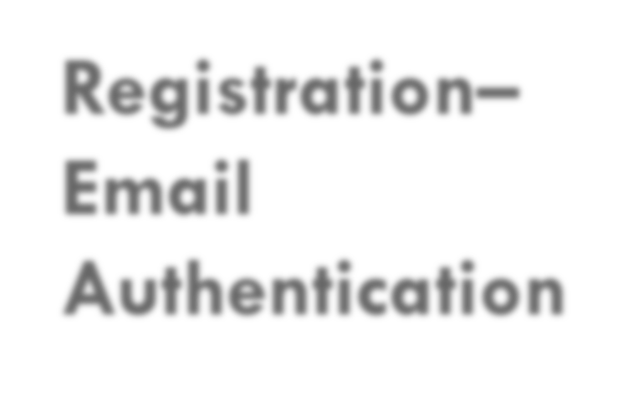
Registration– Email Authentication
Activate your parent account by clicking on the authentication link that is sent to the email provided in step 1.

parent@gmail.com

After clicking the link in step 2, you will be redirected to the WASFA site and will receive the following notification letting you know your account has been successfully activated.

Click “continue” button to proceed.

Please note: You will not be able to log in or access your
account until your email has been validated

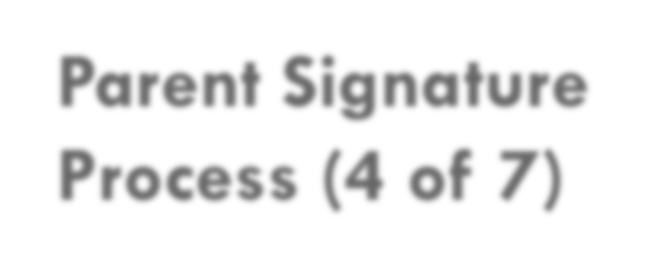
After the parent clicks on Continue, the parent will need to enter their birthdate and last 4 digits of Social Security Number (SSN), or four zeroes if no SSN, to verify their identity. The parent will then be prompted to input their birthdate. Click Done to continue.
Parent Signature Process (4 of 7)

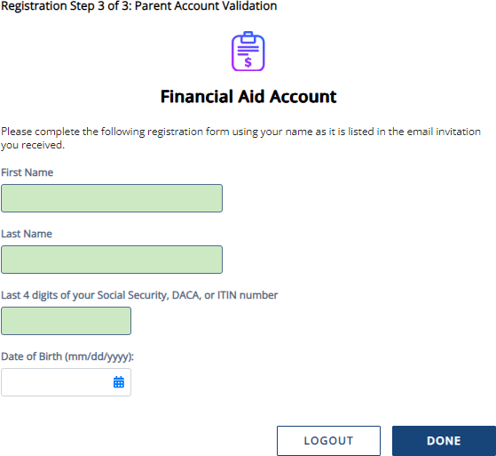
IMPORTANT:
The birthdate and those 4 SSN digits MUST match exactly what the student entered on their application, or the parent will not be able to create an account and sign the application.

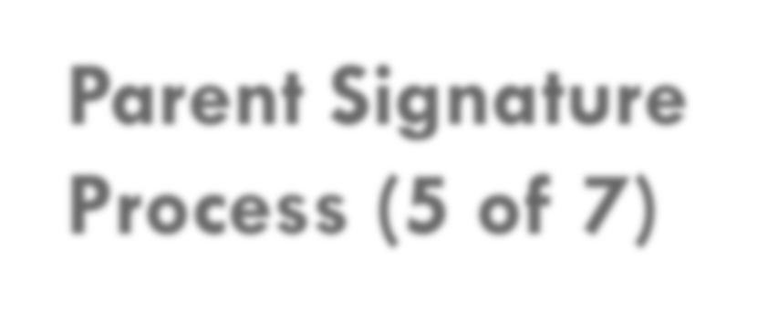
Parent Signature Process (5 of 7)

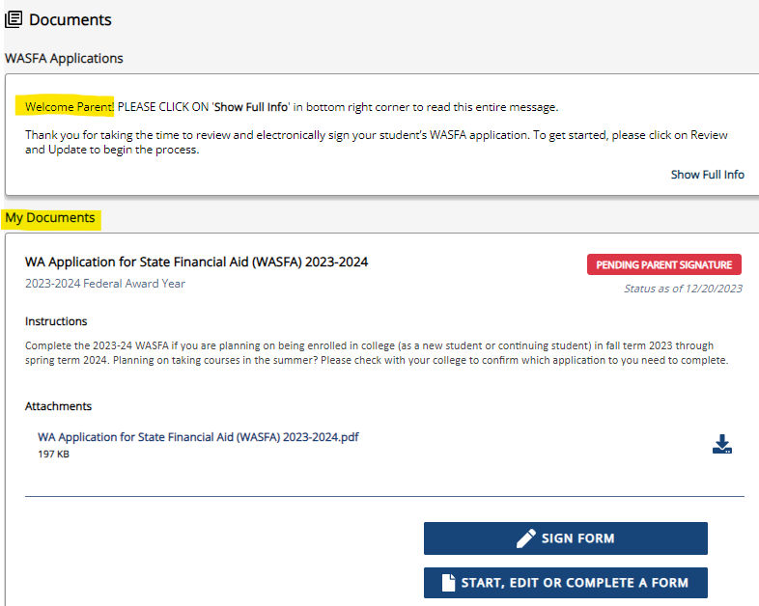
Once you complete the electronic signature section, you will be redirected to the WASFA Documents page. The WASFA application home page will display any applications that are pending the parent’s signature.
Click on the
icon to open the application.

Parent Portal

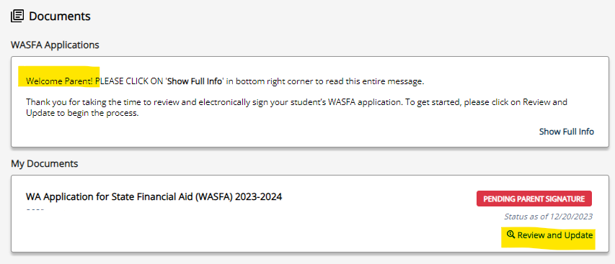
Once logged in, you will be directed to the Documents page. You will be able to tell that you are in the parent portal by looking at the name displayed on the top right corner next to the icon.
The welcome message under WASFA Applications will also say “Welcome Parent!”.

Click “Review and Update” to
continue with the signature process.

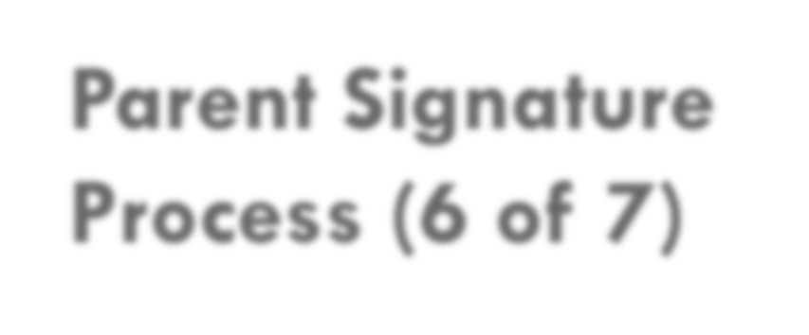
Parent Signature Process (6 of 7)

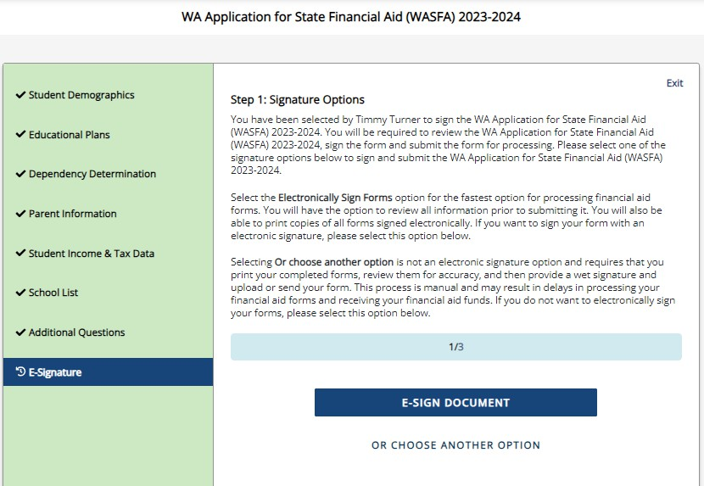
The parent should review the information the student has entered and click Next on each page, all the way to the end of the application.

If any changes need to be made, the parent may make those changes at this time before signing.

Signature Section- Step 2
The parent will repeat the same steps the student
did to complete the electronic signature process.

E-Signature – The View My Forms section is an opportunity to download and review all answers by clicking on the icon. You MUST
open and preview the downloaded form before you can acknowledge that the information is true and correct. Please review answers carefully and make any needed corrections before signing.
The form will open in a separate tab. Once you have viewed it, you can close the tab, check the box acknowledging your information is true and correct, then click Next.

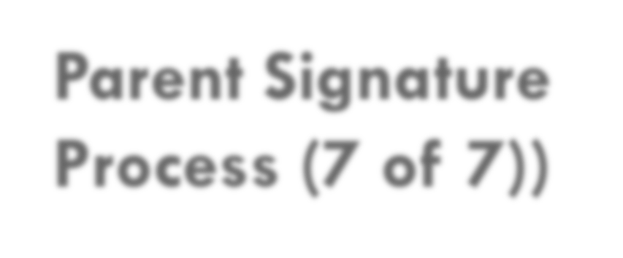
Parent Signature Process (7 of 7))
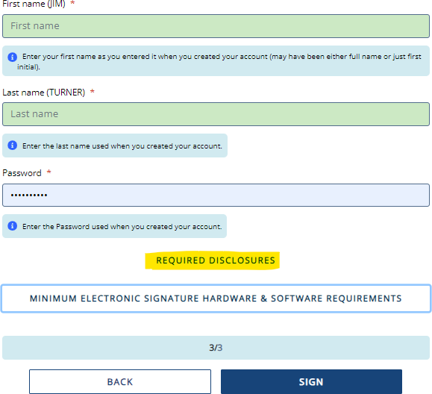
Sign My Forms – Electronic Signature Process. Please read the disclosures, which state that you are certifying the information you provided is true and correct.
Name and password information entered must be exactly the same as when you created your
parent account.
Then click Sign.

E-Signature - Consent & Disclosures

Electronic Signature Consent
& Disclosures.
Please click on and read the required disclosures and Hardware & Software Requirements before signing.

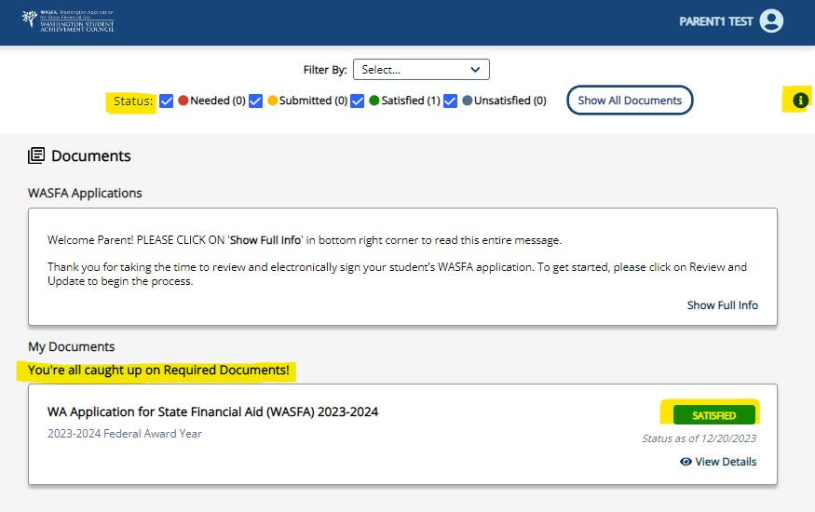
Parent Signature Complete

Once the parent has signed the application, they will be redirected to the WASFA Documents page.

Under the “My Documents” header will display the underlined message on right. The status of the application will also show as

Information & Tips for
After you Complete your Application

- Once your application is complete, within 24 hours your information will be made available to all prospective schools listed in your application.
- The financial aid offices will use the information submitted in your WASFA to prepare a financial aid offer with the amount and types of state aid you are eligible for.
- If you have any more questions about the financial aid award process, timeline, or your EFC, please check with your school’s financial aid office. Only your school can provide you with this information.

Information & Tips for
After you Complete your Application

- If you need to make any changes to your application once you have submitted it, please log back into the Student WASFA Home Page (see Returning Users instructions) and follow these steps:
  - Select the application that needs to be updated
  - Make the necessary changes
  - Save your application
  - Electronically re-sign your application, and if a parent previously signed your
application, you will need to invite them to re-sign the application.
    - You will not be able to edit your application and your schools will not be able
to see your updated application until the parent signature is complete.

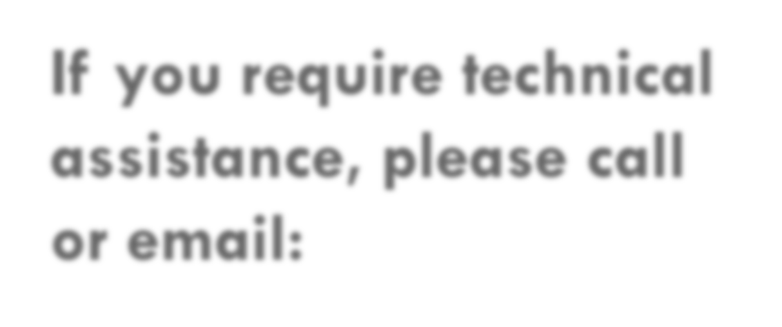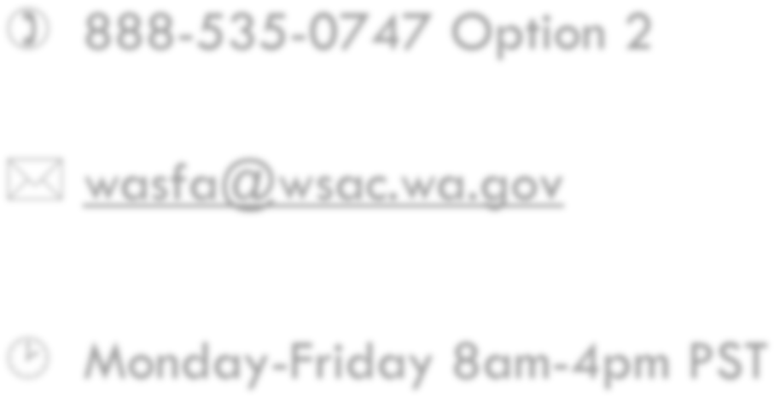
If you require technical assistance, please call or email:
 888-535-0747 Option 2
 wasfa@wsac.wa.gov
 Monday-Friday 8am-4pm PST

